Interim Report
bengo

Part II

FACTUAL REPORT INTERIM PROOF OF USE

The interim proof of use form consists of two parts, both of which are to be submitted via Engagement Global’s application portal (see www.antragsportal.de)

Part I is entered online in the aforementioned application portal. This is where the record of accounts and further clarifications are entered. The record of accounts must contain a compilation all revenues and expenditures during the accounting period.

Part II is the present document in MS Word/Open Office format. This part (the factual report) should be written to allow for a comparison of the objectives/measures stated in the application with the actual implementation of the project. Please note that the total length of Part II should not exceed 10 pages. If this is exceeded by more than 100%, the proof of use will be sent back unprocessed with a request for it to be shortened.

Project number: 5717
Project country: India
Project title: Combatting non-communicable diseases
Private executing agency: Deutsch-Indische Zusammenarbeit e. V.
Project executing agency: Indian Institute of Youth Welfare (IIYW)
Agency number: 10020
Budget year: 2024

- General information
  - Project summary/project objective
[Take from the approved project application; approx. 10 lines]

Overall Objective (Impact):

The NCD project (WLV-5717) aims to spread knowledge and awareness about NCDs within the target group of Urban and Rural Nagpur (villages and slum communities) from the year 2021 to year 2024. As the project aims to raise awareness and sensitisation about the prevalence of NCDs, it is expected that the project will eventually bring about a behavioural change in the target group to detect symptoms early so that the more severe NCDs are curable and risk factors can be largely reduced in advance. The positive effects of the project will be sustainable, especially through the sensitisation of the students and the women's self-help and youth groups, as they can continue to disseminate the knowledge gained beyond the project period independently of the project partners. Furthermore, the development of the knowledge base of the target groups will also lead to a change of perspective and a change in the mindset of the target group. For this reason, the main focus is on the younger generation. Once they adapt to these changes, the positive changes will eventually spread to the older generations. IIYW has already worked in various health-related projects in the region, they are already well connected to the local target groups. Thus, the project will be impactful and will cover a population of around 1,50,000 souls including urban and rural Nagpur in a period of 4 years.

DIZ shall co-operate with IIYW over a funding period starting on 01/02/2021 and ending on 31/12/2024.

The expected project outcomes with respect to the objectives are as under –
• The population in the target area is more sensitive to non-communicable diseases (NCDs) and can make better use of the public health services.
• The direct target group understands that unhealthy living conditions are one of the main causes of non-communicable diseases and that COVID-19 may make it even more vulnerable.
• Village and slum dwellers use the state health facilities.
• School children and college students are sensitised to NCDs and can pass on this knowledge to their families.
• Mediators in the educational institutions, paramedical staff of the NCD cells in the Primary Health Centres (PHCs) as well as members of the women's self-help and youth groups are sensitised and educate the population in the target area, including school children and students, about NCDs.

Sources of information -
[approx. 10 lines]

The data regarding NCDs is being collected from various primary as well as secondary sources. Primary sources involves collection of data through questionnaire surveys from the beneficiary households by personal visits by team of IIYW. The secondary data is procured from the PHCs at the villages and the PHCs from the slum zones and the sub centres in project intervention areas. The required information is also obtained from the Assistant Director Health Service Office (ADHS) of the Nagpur Municipal Corporation (= NMC) and from other hospitals in the blocks of Nagpur.

IIYW has taken the permission from the Health Department of Zilha Parishad (District Government). The Health officer has given acceptance letter for the NCD project and have instructed the medical officers to support the NCD team of IIYW for all kinds of interventions through the NCD project.
The block development officers and Primary Health Centres and the NCD cells have been approached and their permission is also taken for the implementation of project activities. In addition, data on the initial situation of the population and the available health facilities, such as the urban and village health centres and their outposts has been obtained in order to implement the planned project and to be able to measure the results of the project. Schools and colleges principals and teachers have been contacted and their permission is sought for project implementation, The information on health schemes, village level information has also been collected from Gram Panchayat and Anganwadi sewika and ASHA workers, for the purpose of early detection, diagnosis and treatment of NCDs. IIYW has chosen three blocks in Nagpur Rural and two Zones in Nagpur Urban and data on NCDs will be collected , collated and analysed through these areas.

NCD CONTEXT IN INDIA -
- Health systems in India are evolving in alignment with shifting health needs and disease burden with expanded emphasis on Non Communicable Diseases. Realizing the role of prevention and control of NCDs in improving the overall health outcomes and addressing the three pillars of Sustainable Development Goals (SDGs) i.e., economic growth, social equity and environmental protection, it was identified as a prerequisite to accelerate sustainable development. The 2030 Agenda for Sustainable Development adopted by the United Nations in 2015 recognized NCDs as a major public health challenge and included SDG target 3.4 to reduce premature mortality from NCDs by one‐third.
- The National Health Policy (NHP), 2017 recognizes the pivotal importance of SDGs and highlighted the need to halt and reverse the growing incidence of chronic diseases including NCDs. The NHP 2017 defined this objective as “Improve health status through concerted policy action in all sectors and expand preventive, promotive, curative, palliative and rehabilitative services provided through the public health sector with focus on quality.” Addressing the growing burden of NCDs and carving the route towards progressive attainment of Universal Health Coverage (UHC), the policy outlined indicative, quantitative goals and objectives for reducing prevalence and incidence for NCDs, aligned to achieve SDGs in keeping with the policy thrust.
- The National Programme for Prevention and Control of Non Communicable Diseases (NP-NCD) erstwhile National Programme for Prevention and Control of Cancer, Diabetes, Cardiovascular Diseases and Stroke (NPCDCS) was launched in 2010 in 100 districts across 21 states with an objective to prevent and control major NCDs. The programme was scaled up in a phased manner and now covers all the districts across the country. The focus of NPCDCS was to enable opportunistic screening for common NCDs at District Hospital and Community Health Centres level, through the setting up of NCD clinics. iv. In order to expand the services and bring them closer to the community, Population Based Screening (PBS) for common NCDs was launched in year 2016. The PBS includes screening of individuals of 30 years and above age group for five common NCDs i.e., Hypertension, Diabetes, Cancers of the oral cavity, cervix and breast. The key components of this initiative include population enumeration, assessment of risk factors, mobilizing communities for screening at Sub-Centres (SC), Primary Health Centres (PHC) in rural and urban areas, health promotion, initiation of treatment at a PHC, referral to higher centres for further treatment, if required. Both upward and downward referral, follow up is provided under the programme to ensure continuum of care 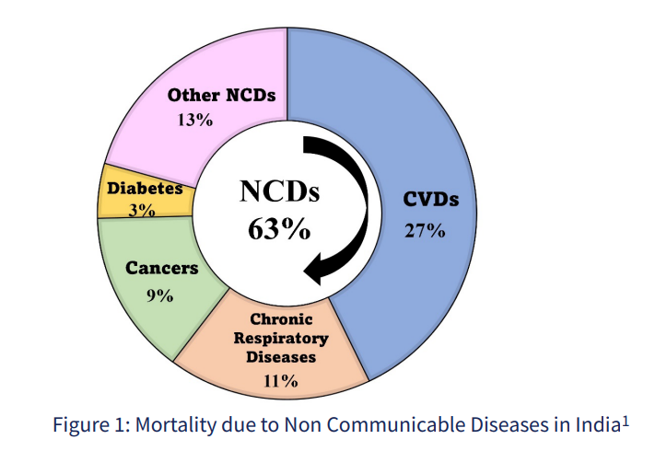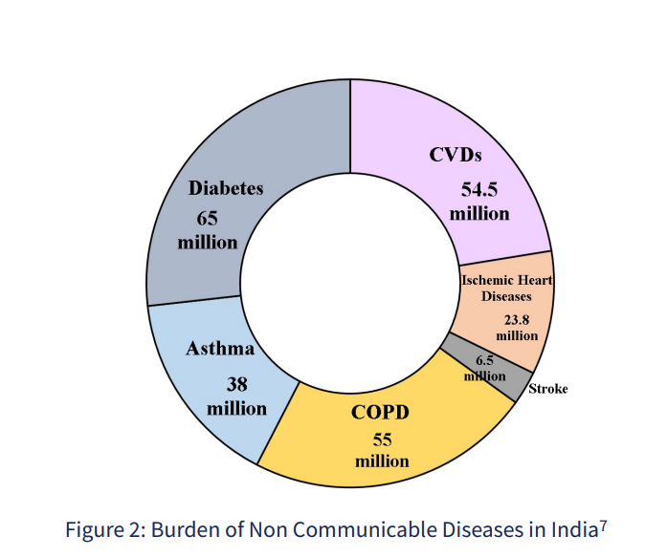
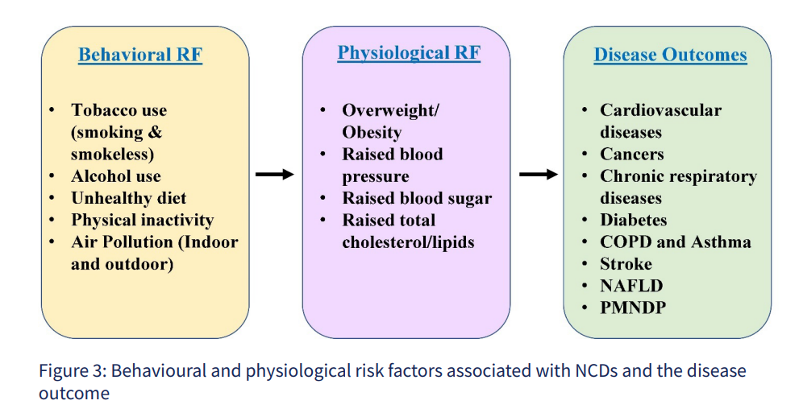

- Status of the project’s implementation-
Sub-objectives  (output) | Indicators (if possible, also specifying quantity)
Sub-objectives  (output) | Actual situation  (quantitative and qualitative) | Target situation (objective)  (quantitative and qualitative | Achieved situation  (quantitative and qualitative)
1. The direct target group understands that unhealthy living conditions are one of the main causes of non-communicable diseases and COVID-19 may make them even more vulnerable. | People affected by NCDs and their families are aware that they suffer from certain health problems but are unable to recognise them as diseases that are treatable or whose causes lie partly in their own actions. | - 75 % of the target group is aware of the connection between the occurring health problems and non-communicable diseases - also in the context of COVID-19.  - 25 % of people affected by NCDs change their own behaviour based on this knowledge and minimize personal risk factors. This can be observed through a change in diet, constructional changes in kitchens, planting trees or creating kitchen gardens. (in each case this can be observed through random representative surveys of 5 % of the target group) | ``Awareness and education programmes on NCDs in 36 villages and 6 slums were organized. (~5819 souls were trained through 1 day or half day training organized at various villages / PHCs /Schools or at communities).  ``About 1093 women from the “Self Help Groups” have been trained in Non Communicable diseases prevention -strategies and small actions, through lecture demonstration method.  ``NCD related rallies for Mass awareness were organised in 5 villages through the women’s self help groups with 235 women participated in it to wide spread the awareness. Reach out is 36 villages -7600 villagers as indirect beneficiaries.  ``96 adolescent girls from 8 slums and 9 villages were imparted training on life skills and reproductive health and also on combating NCDs at home level.  ``Knowledge about better Hygienic practices and self-care were also imparted during 1 day workshops.  ``The women from villages (around 356 souls ) are linked to Government schemes that are given by the Government namely Ayushyaman Bharat, PMSBY scheme, food processing scheme, tailoring machine scheme, nursery set up etc. through NCD scheme. This is to involve the women in the process of NCD awareness and NCD prevention. As per the records of PHCs, more  registrations and visits by women to PHCs have been increased.  ``Through observation, it is noticed that women in intervention areas have changed their lifestyles and included exercise, walking and nutritious food as the way of life.  ``Post impact assessment questionnaires have been developed and feedback is taken from the villagers and residents of the communities which has revealed that more than 85% of the target group are now aware about NCDs, its causes and are practising better living habits and taking nutritious food.
2. Village and slum dwellers use the government health facilities | Treatment options exist but are rarely or not at all used due to lack of awareness. The direct target group is not aware of the public health services and therefore does not use them. | 75 % of the direct target group are aware of the (treatment) options offered by government health facilities and the need to visit them for prevention or early treatment. - 25 % of the people affected by NCDs consult government health centres regarding NCDs. (in each case this can be observed through random representative surveys of 5 % of the target group) | ``Accessibility of rural population to Government medical Facilities and services has enhanced through IIYW’s interventions in villages and communities in urban areas.  ``In the year 2024 in 37 villages, more than 95 cases of diabetes, 16 cases of heart related diseases, 204 eye related illness and 264 low HB cases were identified.  Number of patients of NCDs linked to PHCs –  Kalmeshwar Block – 452 patients  Saoner Block – 1132 patients  Kampthee block – 642 patients  Schemes of Government availed by the patients  -Ayushyaman Bharat Yojna - 356  -ABHA yojna - 356  Lek Lakki Yojna - 84  Life insurance scheme - 22  Other schemes like Micro Finance scheme - 30  Stree Shakti Yojna - 56  ``This has been done by the IIYW team who conducted door to door visits to aware people about the importance of treatment and available options towards treatment of NCDs.  ``All PHCs (list indicated in this report) have been visited and data saught on the NCDs percentage and other NCD related schemes etc which are promoted by Government. This includes Health schemes, health insurances, treatment options, palliative care etc. This has been possible because of the efforts of Government and also the support of NCD project team.  ``The post impact assessment questionnaire indicates a 88% population covered under NCD project have enhanced awareness about treatment options and services by the Government PHCs.
3. School children and students in colleges (36 educational institutions with 10,800 school children/students) are sensitised to NCDs and can pass on this knowledge to their families. | School children and college students receive little or no information about NCDs during their school and college years or afterwards in their professional lives. | 50 % of school children and college students (from 36 schools/colleges with an average of 300 persons each) have understood the connection between personal behaviour and NCDs and are pass ing on this knowledge to their (family) environment. (can be observed by school competitions and by random representative surveys of 5 % of the mediators) | ``Screening of BMI, random sugar and BP has been undertaken in schools and colleges in urban and rural areas on quarterly basis and results are shared with the teachers.  ``96 Adolescents (girls and boys) have been given workshops and training on prevention and life style related diseases. They participated very well in entire and supported NCD team for spreading mass awareness about NCDs and its minimisation at village level.  ``To motivate students from Government schools towards prevention of NCDs, IIYW undertakes NCD related competitions such as poster and essay competitions and quizzes for the students. 517 students from 14 schools have participated enthusiastically and this methodology helped them understand the issues related to prevention and management of NCDs.  ``Nutrition day and Global hand-washing day has been celebrated in schools and communities which has had a participation more than 500 students/women from communities.
4. Mediators in the educational institutions (professors, teachers at government schools, approx. 1,080 persons), paramedical staff of the NCD cells in the PHCs (approx. 37 persons) as well as members of the women's self-help and youth groups are sensitised and raise awareness about NCDs among the population in the target area, including school children and students. | At the beginning of the project, mediators are hardly or not at all able to educate the population in the target area, including school children | 90 % of mediators are informed about NCDs - 75 % of the informed mediators are able to educate others about NCDs on their own and 50 % of the educational institutions have addressed the issue of NCDs in extracurricular activities that take place at least once a year. | ``IIYW continued with capacity buiding of para medical staff of PHCs and Anganwadis and ASHA workers including doctors,ASHA workers nurses, school teachers, Anganwadi Sewikas, who are the mediators of the change.  ``Continued Medical Education for doctors and nurses have been organised for the entire year at various PHCs.  ``197 medical professionals and para medical trained -Laxmi Nagar - 62, Dharampeth zone - 70, Patansawangi Gram Panchayat – 25 and Kalmeshwar panchayat Sammitte -70  ``207 (Doctors, nurse and paramedical professionals -ANM, GNM ) are trained through expert doctors in prevention and management of NCDs.  ``82 ASHA workers undergone 1 day workshop at 2 places in urban and rural set up and are updated about 4 , main NCDs and its management and palliative care related issues.  ``56 Women leaders were trained in Nutrition related anaemia and the solutions to tackle it through nutritious recipes and organic kitchen gardens  ``82 para medical staff has been trained through experts and doctors in giving a proper and scientific CPR in case of a heart attack. Practical demonstrations have been organised. 2 PHCs have supported by allocating hall, space and also making available the para medical staff for CPR-lecture and demonstration.  CPR meaning Cardiopulmonary Resuscitation which is an emergency life saving procedure that is done when someone’s breathing or heartbeat has stopped.  Note - the statistics -village wise and community wise have been given in the tables below. | +
CUMMULATIVE IMPACT OF NCD PROJECT - (YEAR 2021-2024)
In 4 years from 2021 till 2024, 1,60,000 souls have been covered with various interventions of NCD which encompasses main activities like focused awareness on NCDs with different groups, capacity building and perspective building on management of NCDs with Primary Health Centres staff and training of animators/change agents . NCD team also widely worked with younger generation towards the prevention of NCDs with Government and Private schools and engaged them in this issue of health and NCD prevention with proper lifestyle from this early age in their lives.
During the 4 years, IIYW NCD team saught the support from Dr. Prabhakar Deshpande, Senior Physician from Nagpur and renowned doctor and Dr. Mrs. Mrudul Chande, Senior Gynaecologist from Nagpur, Dr Lalita Mahajan on stress management and Dr. Kamal Chhabrani renowned ophthalmologist on eye care.
In addition, we took the support of Sahayak Trust for knowledge building on Anaemia and development of organic kitchen gardens in more than 40 villages of intervention.
All PHCs have given their halls / space free of cost for activities of NCD project and also encouraged participation of their staff in all our activities.
The gram Panchayat sarpanch and other members have always welcomed the NCD team and offered free of cost hall for organising workshops and health screening camps for all target groups.
PHCs doctors and other paramedical staff have participated actively in all objectives of NCD project and have been very helpful throughout the 4 years interventions.
IIYWs NCD team worked extensively to meet the objectives of the project and make people aware about NCDs and the importance of proper diet, medicines and other social and environmental factors.
IIYW team tried to cover remote villages where medical support is less and awareness is low. This has been a challenge to convince them about seeking medical support from PHCs and about regular medication etc.
In last 4 years, Government of India has also come up with newer initiatives in the management of NCDs and new schemes have been launched at Central and State level which will benefit the population in general and NCD patients in particular.
In 4 years, NCD team has established very good with villagers and Gram Panchayat members, PHCs , ASHA workers and Anganwadi workers and other staff of Government facilities which has helped saught support from all around the localities of interventions. NCD team motivated the villagers/ communities by organizing various interesting programmes with them and through that conveyed the message of NCDs and brought about awareness. Involvement of Renowned doctors and experts has helped saught the participation in all the programmes. The Sarpanch and all other stakeholders are demanding further work with their communities for the benefit and welfare of population. All interventions of NCD project have been appreciated by all stakeholders.
IIYW has given the stakeholders courtesy gifts with NCD messages for their willing support through out the project period.
Supplementary explanations of deviations from the planning –
No deviation from the planned-

  - Status of the implementation of the measures (in comparison to the application)

The project targets have been successfully achieved for the year 2024 by Indian Institute of Youth Welfare. The team has successfully reached out to 35 slums and 64 villages as per the population specified in the proposal through training, mass awareness and rallies and other interventions on NCDs in urban and rural Nagpur. (refer table below)

Population covered in Urban and rural Nagpur –
URBAN  area in Nagpur District | Name of area (urban/rural) | Number of localities covered in 2024 | Households covered in 2022 | Households covered in 2023 | Households covered in 2024
URBAN  area in Nagpur District | Dharampeth zone | 20 slums | 1500 | 1590 | 1880
URBAN  area in Nagpur District | Laxminagar zone | 15 slums | 3069 | 4200 | 4380
RURAL area in Nagpur District | Kalmeshwar | 22 villages | 1358 | 1540 | 1790
RURAL area in Nagpur District | Saoner | 20 villages | 2260 | 2300 | 2650
RURAL area in Nagpur District | Kampthee | 22 villages | 1560 | 1560 | 1850
RURAL area in Nagpur District | Total number of households covered |  | 9747 | 11,190 | 12550

Strategies adopted -
``The target population is addressed through various participatory tools such as Continuing Medical Education (CME) programmes, Behaviour Change Communication (BCC) programmes, use of social media for communication and delivery of workshops and training programmes, Information, Education and Communication (IEC) activities and Interpersonal Communication (IPC) activities to build a good and trustful relationship with the target group.

The activities essentially entailed advocacy and capacity building for trust through the involvement of the entire community (NGOs, ASHA, SHG, ICDS, Teachers, youth, educated adults returning to the village) and the Gram Panchayat.
- Community Engagement and mobilisation
- Capacity Building
- Awareness Generation
- Support (Relief, supplies, travel etc.)
- Involvement in the Village Task Force, need to include block and district
- Laisoning with SHGs, Tribal leaders, Gram Panchayats, youth groups etc.
- Laisoning with Government -
- Focused on hygiene, nutrition, counselling (PSS) components
- Special emphasis was provided to women and their nutrition needs and development of organic kitchen gardens

5.2.1 (regarding project objective 1): The direct target group understands that non-communicable diseases are one of the main causes of unhealthy living conditions.

MAJOR ACTIVITIES UNDER NCD PROJECT IN LAST 4 YEARS-
Activites under NCD project | 2021 | 2022 | 2023 | 2024
Vilages covered | 65 | 42 | 54 | 36
Slum communities covered | 16 | 33 | 16 | 16
Anganwadi centres covered | - | 81 | 58 | 88
Number of school students covered | - | 679 | 500 | 1093
Competitions in schools and with women | 1678 | 566 | 250 | 517
Number of programmes on Nutrition with adolescents |  | 134 | 334 | 96
Number of plants planted at various locations | 450 | 550 | 201 | 630
Number of organic kitchen gardens developed | 4 | 30 | 112 | 173
Number of BP cases identified and linked to PHC | - | 368 | 680 | 859
Number of Anaemia cases identified and linked | 25 | 270 | 275 | 254
Number of cases linked with Government health facilities | - | 9747 | 11190 | 226
Participation in Rallies on hand-washing days/environment day or awareness on NCD diseases organised at various locations | 120 | 375 | 311 | 235
Puppet shows and street plays during Covid19 awareness | 490 | - | - | -
CPR programmes  With PHCs | - |  | 680  (7 PHCs and 3 colleges) | 382  (2 PHCs and 2 Anganwadis and 3 Government offices and 3 schools )

Measures against air pollution-
630 plant saplings were distributed and also seeds were given for development of OKGN (organic kitchen grdens) at individual level. On the same day, world environment day rally was organized at the Lonara Campus and a total of 350 trees were distributed in different villages.
Measures to improve the nutritional situation-
Till 2024 end, through NCD project - 173 organic kitchen gardens have been developed at common places or at individual households by the residents of villages.
5.2.2 (regarding project objective 2): Village and slum dwellers use the state health facilities.

``IIYW NCD team has developed good rapport with PHC, UPHC, Asha workers, Nurses, Anganwadi Sewikas, Schools, Colleges, Gram Panchayat, Self help groups, Supervisors, Local leaders, Health departments and education department have linked to NCD-IIYW project.
NCD cases identified and linked to State Governments facilities -
 | Cases /Year | 2021 |  | 2022 |  | 2023 |  | 2024 |  | Total
 | Cases of high blood pressure | - |  | 368 |  | 680 |  | 859 |  | 1907
 | Cases of high blood sugar | - |  | 600 |  | 680 |  | 570 |  | 1850
 | Cases of heart related ailments | - |  | 162 |  | 204 |  | 101 |  | 467
 | Cases of eye diseases | - |  | 200 |  | 204 |  | 280 |  | 684
Zone / community/block |  |  | Eye related diseases  Registered cases |  | Depression /stress related cases |  | Heart related ailments |  | Anaemia related cases (low haemoglobin cases)
Kalmeshwar block |  |  | 67 |  | 62 |  | 459 |  | 64
Saoner block |  |  | 42 |  | 29 |  | 101 |  | 80
Dharampeth Block |  |  | 41 |  | 14 |  | 78 |  | 16
Laxminagar block |  |  | 38 |  | 4 |  | 43 |  | 30
Total cases registered with PHC |  |  | 188 |  | 109 |  | 681 |  | 190

NCD RELATED SACREENING AND IDENTIFICATION AND LINAKGES OF NCD CASES -

Health camp in villages = 36
Health camp assistance by NCD team -
Pipla, Zunki, Waroda, Gosewadi (2 camps), Khandala, Lonara
Rallies were organised for awareness on Dengu, malaria and World Heart day, World TB day, World Hand washing day, world eye care day, world diabetes day at various communities. 234 people along with 125 children participated in the rallies for awareness.
Screening of population = 2175 souls
BP check = 859
Testing of HB = 264
Random sugar check up = 385
Eye check up = 101
Cataract operations = 35 people
Eye check up for school students = 30

Population from various villages were linked to available Government schemes on Health.
In addition, tree plantation programmes have been undertaken in almost all villages where plants were distributed and also planted through peoples participation@Sawarmendha, Lonara, Gumthi, Bhendala.
Bhendala village is also supported with plants and seeds for the organic kitchen garden which has been developed jointly with the Gram Panchayat.
A total of 179 organic kitchen have been developed with the guidance from NCD team in villages isapur, goswwadi, sahuli, waroda, ghorad, ubali, manegaon, walni, sawarmendha, dahegaon, pipla. Chakki khapa, wakodi, pipla kinkhed, mendhasawangi.
Ayushmaan Scheme = 366 people
ABHA CARD = 356 people
Lek Ladki Yojna = 84
Matrutva Yojna = 75
Health Insurance = 22
Micro finance schemes = 30
Stree Shakti Yojna = 56

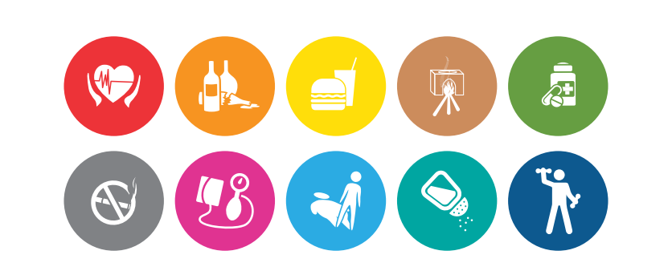

5.2.4 (regarding project objective 4): -
Networks developed through NCD project -
``IIYW is working with a mission of Anaemia free villages and are spreading awareness about Anaemia and the remedies to deal with it and preventing it through various means such as diet changes, exercises, treatment and follow ups. IIYW has found the need of testing of Haemoglobin for women in the age group of 15 to 49 where women used to complain about weakness, low energy, weight loss, giddiness etc. In 2024, HB testing was carried out in Kalmeshwar, Kampthee and Saoner block and in Dharampeth and Laxminagar zone. The screening was done through the pathologists team. Out of 190 women screened for HB, about 8 women had anaemia (HB too low, below 8mg) and 18 were in the range of HB~ 9 to 11 mg. Thus, IIYW NCD team linked them to the Primary Health Centre and these women are getting proper treatment to reduce the anaemia and iron deficiency. They have been made aware about the nutritious food which they can consume daily which is affordable. Local foods like millets are promoted for the health of women. Women are now keen on taking nutri food and also feed their kids with nutritious recipes.

At the same time, the women are screened for the random sugar levels. The women who have been detected with high sugar levels were linked to PHCs for their treatment. Some women were diabetic already and they have also been pursued to take regular medicines and include exercise for the management of sugar levels. 70 such women with high Blood Sugar levels got the treatment at PHC and they are continuing with the same.

``Awareness with women in villages and in slum communities was undertaken through NCD project. Nutrition and Anaemia related sessions have been taken in 13 villages and 3 slums communities thus reaching out to 1189 women from self help groups. Awareness involves the group discussions, IEC display. Role plays and other means such as flip charts, competitions etc. The adolescents mainly girls are reached out 96 adolescent girls in 4 slum communities/villages. They were given sessions on Life Skill Education and NCD prevention and role of healthy diet and healthy life style. In addition, 62750 general population was reached through mass awareness methods such as posters/ audio announcements/door to door campaign/ nukkad meetings/focused group discussions etc.

3.Assessment of the ongoing course of the project by the private executing agency

Nil

- Additional remarks

As the year 2024 was the last year of intervention with target areas /localities/villages, IIYW also focused on NCD cases, their linkages with Government facilities and the follow up of previously identified cases on 4 chosen NCDs. Support to PHCs towards organising health screening camps have been undertaken and the NCD cases are thus linked and further identified and existing cases were linked to PHCs. This has ensured that the NCD cases are regularly taking medicines from Government Facilities and are following themselves with the PHCS for management of their existing NCDs. This will ensure a secured life for them as they get regular and proper medicine on their identified NCDs.

IIYW has devised questionnaires to assess the outcome of the programme of 4 years with low income communities and villages in 3 blocks. The questionnaire was filled by the field officers and the analysis of the same reveals that the villagers have become aware of their life styles and related diseases. The women and children and population in general has understood the importance of healthy diet and exercise and proper medication for the management of NCDs. More percentage of NCD cases seeking regular medical support from PHCs is seen as compared to year 2021.

Special attention has been given to 4 NCDs namely heart related diseases , Anaemia and women's health, eye care for students and geriatric patients, stress management and lung related diseases. Focus has been given on awareness on changing habits of consuming alcohol, smoking and diet related concerns. Patients were linked to nearby PHCs and ASHA workers have been further empowered through regular workshops and capacity building measures by the NCD team.

NCD impact assessment tools -
- Post impact assessment questionnaire at household level
- Case studies of beneficiary -122 people have been identified and case stories of their NCD related initiative have been recorded as case story.
- Random samples for NCD satisfaction survey with women - 68% women have shown immense satisfaction for the NCD interventions in last 4 years.
- Quizzes and Interviews with PHCs and other stakeholders -20 schools - scored more than 80 percentage marks in the final quiz organised at the end of the project.
- Anganwadi related outcomes -
- HB testing
- Nutrition corner
- Vaccination follow ups
- Organic kitchen gardens
- Diet charts
- Impact assessment tools developed by IIYW -
`Post Impact Assessment Questionnaire for Household level (in marathi) -
` Feedback questionnaire for NCD stakeholders-
``Interviews with Gram Sarpanch and other stakeholders -
``NCD awareness survey with women from villages and communities-
``Quiz and competitions on NCD’s at educational institute level
Datum [as in Part I]:

NCD PROGRAMMES IN THE YEAR 2024
S. No | Name of village/community | Purpose of the programme | Date of the programme | Target group | Number of Participants
1 | Godhni | Awareness programme on life style diseases for women | 19/1/2024 | Self-help group women and other women | 150
2 | Simtakli | Awareness on Nutrition for women | 20/1/2024 | Self Help group | 20
3 | Godhni | Awareness on NCDs and Anaemia | 20/1/2024 | Self Help group | 65
4 | Lonara | Awareness on TB and Hepatitis B and C | 25/1/2024 | ICTC staff | 65
5 | Bhendala | Awareness on NCDs and Anaemia | 1/2/2024 | SHGs from village | 35
6 | Walni | Awareness on TB and Hepatitis B and C | 2/2/2024 | SHGs from village | 32
7 | Gosewadi | Awareness on NCDs and Anaemia | 3/2/2024 | SHGs from village | 40
8 | Pipla | Awareness on TB and Hepatitis B and C | 5/2/2024 | SHGs from village | 30
9 | Dahegaon Rangari | Competition and school level interventions | 9/2/2024 | School students | 18
 |  |  |  |  | 410

S. No | Name of village/community | Purpose of the programme | Date of the programme | Target group | Number of Participants
1 | Sim takli | Awareness and competitions on iron deficiency anaemia - Nutritious food and low-cost recipes . | 20/1/2024 | Adolescent girls and women from Self help groups | 15
2 | walni |  | 2/2/2024 | Adolescent girls and women from Self help groups | 20
3 | Pipla |  | 5/2/2024 | Adolescent girls and women from Self help groups | 15
4 | Itanghoti |  | 22/3/2024 | Adolescent girls and women from Self help groups | 10
5 | Chakki khapa |  | 18/7/2024 | Adolescent girls and women from Self help groups | 20
6 | Pitesur |  | 7/8/2024 | Adolescent girls and women from Self help groups | 10
7 | Futala |  | 20/2/2024 | Adolescent girls and women from Self help groups | 9
8 | Godhni, Simtakli, Pitesur,  Pipla, Dahegaon rangari, Kamgaar Nagar, Futala, Itanghoti, Chakki khapa |  | 19/1/2024  20/1/2024  25/1/2024  31/1/2024  1/2/2024  3/2/2024  5/2/2024  15/2/2024  20/2/2024  22/2/2024  4/8/2024  7/8/2024 | The women from self help groups were made aware about importance of diet and low cost recipes so as to deal with iron deficiency anaemia, through experts and NCD team through IEC and workshop. | 150  20  65  65  35  32  40  30  18  10  72  42
 |  |  |  |  | 683

S. No | Name of village/community | Purpose of the programme | Date of the programme | Target group | Number of Participants
1 | Sawarmendha | Follow up meeting with Gram Panchayat Members  Updates about NCD programmes and organic kitchen gardens status and health screening etc | 25/1/2024 | Gram Panchayat Members | 40
2 | Godhni |  | 25/1/2024 |  | 32
3 | Kalmeshwar |  | 11/6/2024 |  | 6
4 | Warora, Ubali, Ghorad, Brahmapuri, Sillori, Kampthee, Kampthee, Sarpanch and Dy sarpanch , lonara and Bokhara |  | 14/6/2024  19/6/2024 |  | 15  5  21
 |  |  |  |  | 119

S. No | Name of village/community | Purpose of the programme | Date of the programme | Target group | Number of Participants
1 | Gosewadi | Organising various competitions at village level or school level | 3/2/2024 | Gram Panchayat Members | 20
2 | Dahegaon |  | 18/2/2024 |  | 25
3 | Old Futala community |  | 16/11/2024 |  | 15
4 | Dahegaon |  | 12/3/2024 | School students | 40
5 | Sawarmendha, dahegaon, futala, warora, bhendala | Poster competitions on subject of NCDs | 9/2/2024  13/8/2024  30/9/2024 | Zilla Parishad school | 172
 |  |  |  |  | 272

S. No | Name of village/community | Purpose of the programme | Date of the programme | Target group | Number of Participants
1 | Telangkhedi | Awareness on CPR programme for surviving heart attack struck person for ASHA workers and Nurses | 22/3/2024 | ASHA WORKERS , NURSES AND PARA MEDICAL STAFF | 52
2 | Sawarmendha |  | 13/8/2024 |  | 30
3 | Women’s day programme | Role of women in preventing NCDs | 25/6/2024 | Women from villages of Saoner block and Kalmeshwar block | 56  34

The feedback from stakeholders over NCD interventions by IIYW team-
During the end of the project, IIYW team collected the feedback from stakeholders with whom IIYW has collaborated during the 4 years of project implementation. This includes the local Government, Primary Health Centre and Self help groups, ASHA workers and Anganwadi Sewikas, school head masters/head mistresses etc.
IIYW contributed to the betterment of NCD related health status of concerned 65 villages and 33 slum communities in last 4 years from Feb 2021 till Dec 2024.
IIYW has collected the feedback in form of feedback questionnaire which was filled by the respective stakeholders such as Sarpanch or members of local Government (Gram Panchayat), doctors from PHCs , Anganwadi workers or Supervisors from Anganwadi and teachers from schools. The feedback from stakeholders have been very positive and they have appreciated the NCD work carried out by IIYW in last 4 years.
For the stakeholders who visited IIYW campus for the NCD related workshops, the feedback has been collected in similar formats. This has become a tool to assess the impact of the 4 years interventions.
At the closure of the project, IIYW has given them small token such as pen and dairy with health related messages.
The second half of the year 2024 focused on incapacitating the gram panchayat and other stakeholders to take the work forward after the project closure. Thus, several meetings with head of the organisations/institutions involved in NCD related work have been contacted and regular meetings have been undertaken to empower them. In addition, PHC’s were requested for the organising health screening camps which they did. This has given us data on awareness about health check ups by the communities and villages. The health screening focused on the villages where the percentage of NCD’s have been found more and also where the awareness was low (as per the base line of 2021 base line surveys).
The 4 years NCD programme enlightened many stakeholders involved in the health sector who were associated with NCD programme of DIZ/BMZ. The knowledge of all stakeholders have been enhanced through different training and capacity building programmes through expert medical professionals. Full day workshop were organised for Primary Health Centres and Anganwadi centres.
The overall interventions under the NCD project focused on minimizing 4 main NCDs -
Major activities relating to -
``Reduction of Anaemia in women of age group of 19 to 49 (Mainly iron deficiency anaemia)
``Prevention and management of heart diseases (life style changes and linkages with health facilities of Government)
``Management of eye care and geriatric eye care (awareness on Self care and Cataract Operations)
``Prevention of stress and high BP related management (awareness on self-care and treatment)

Government of India has taken also taken up NCD as major concern and few interventions have been initiated-
Initiatives and programmes taken up by Government of India have been a supportive point for the initiatives taken up y NCD project of IIYW under the DIZ/BMZ. The PHCs have got a good support in terms of knowledge building and implementation from the NCD team of IIYW. In the final feedbacks given by the multi level stakeholders, all have shown satisfaction with the NCD project support.
The villages have also shown keen interest in receiving the knowledge on NCDs and the life style changes that are required for the prevention and management of NCDs. Many Gram Panchayats and Anganwadis in the target areas and many PHCs have taken up NCD as a key focus through their interventions as well. This will help IIYW/DIZ to sustain and continue the initiatives taken in last 4 years towards prevention and proper management of NCD cases.
Awareness generated through different social tools have helped the existing NCD patients to get themselves linked to PHCs or other Governament facilities and then to take proper medication from qualified doctors instead of relying on traditional ways of healing at villages.
Women have become more specific about nutritional food intake and also feeding their children with more nutri foods in order to preserve and conserve their health. Schools in the intervention areas have started the initiatives of NCDs and Nutri Gardens in their premise as well. They use the green vegetables from organic kitchen garden at home or at schools.
The gram panchayats / Local Governments have taken up new initiatives to motivate the villagers and communities through rallies and otgher platforms to combat NCDs in their communities. Women have been seen to be taking lead role in prevention of NCDs at home whereas the teachers and staff at their respective schools.
PROGRAMMES BY GOVERNMENT OF INDIA -
NCD TEAM OF IIYW have studied the following social benefit schemes of Government of India. They have linked more than 50% patients with the below relevant schemes. This will help the NCD patient to available services of Government either free of cost or as per the schemes proforma. The available schemes are as under-
Ayushman bharat is a national health protection scheme launched by the government of india. It aims to provide health insurance coverage up to 5 lakh rupees per family per year for secondary and tertiary care hospitalization to over 10 crore poor and vulnerable families. The scheme has two sub-components: Pradhan mantri jan arogya yojana (PM-JAY) and health and wellness centres (hwcs). Pm-jay provides universal health coverage to the poor and vulnerable sections of society
The Ayushman Bharat Health Account (ABHA) is a health ID developed by the Indian government.
This will allow you to easily share your health data such as health records and diagnostic records with healthcare providers.
The Ayushman Bharat Health Account (ABHA), which was earlier known as Ayushman Bharat Health ID was launched by the Indian government in 2021 and is aimed at providing a digital health ID to the population.
This was launched by the National Health Authority (NHA), which is part of the Ministry of Health and Family Welfare. As per the government, ABHA is the “first step towards creating safer and efficient digital health records for you and your family.”
Lek Ladki Yojana has been implemented by the Maharashtra government for the upliftment of the girls of the state. Through this scheme, the government will provide financial assistance to girls from their birth till their education, so that their standard of living can be improved.
The Pradhan Mantri Matru Vandana Yojana (PMMVY) is a Centrally Sponsored flagship scheme by the Ministry of Women and Child Development, Government of India, designed to support pregnant women and lactating mothers. The scheme is to provide maternity benefits to women belonging to socially and economically disadvantaged sections of society. The maternity benefit is to be provided to a woman for the first two living children provided the second child is a girl. For the first child the maternity benefit of ₹5,000/- is provided in two installment under PMMVY and the beneficiary is also entitled to receive the cash incentive as per approved norms towards Maternity Benefit under Janani Suraksha Yojana (JSY) after institutional delivery so that on an average, a women gets ₹6,000/-. For the second child, the benefit of ₹6,000/- is to be provided subject to second child is a girl child, in one installment after the birth. Cases of miscarriage/still births are to be treated as fresh cases for providing maternity benefit under the scheme.
Mahatma Jyotirao Pule Jan Arogya Yojana- The Mahatma Jyotirao Pule Jan Arogya Yojana is the flagship health insurance scheme of the Government of Maharashtra1. It provides end-to-end cashless services for identified diseases through a network of service providers from the Government and Private sector1. Under this scheme, people in the state can avail the benefits of free and cashless health insurance2. Maharashtra is the first state in India to offer a universal healthcare policy, co-branded with the Centre's Ayushman Bharat scheme3.

The SBI Stree Shakti Yojana was launched with the primary objective of supporting women in their entrepreneurial journey. By providing financial aid, SBI aims to eliminate the barriers that women face when starting their own businesses. The scheme encourages women to take the plunge into entrepreneurship, contributing to their financial independence and the overall economic growth of the nation.

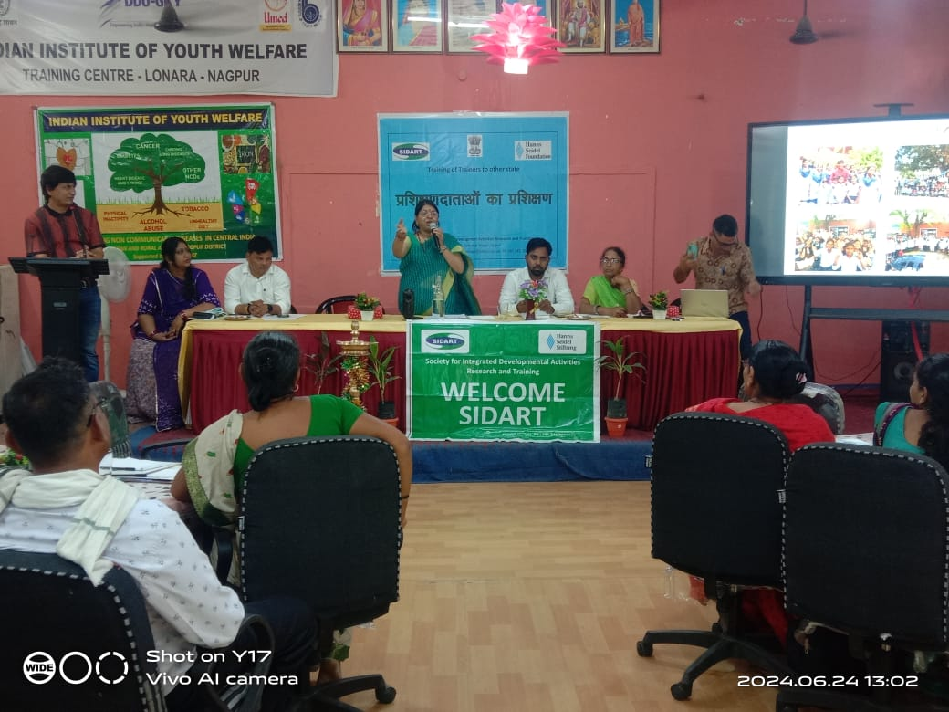
Joint programme on Village Development and Prevention of NCDs with SIDART for Sarpanch and Dy Sarpanch from various blocks of Nagpur District -24 and 25 July 2024

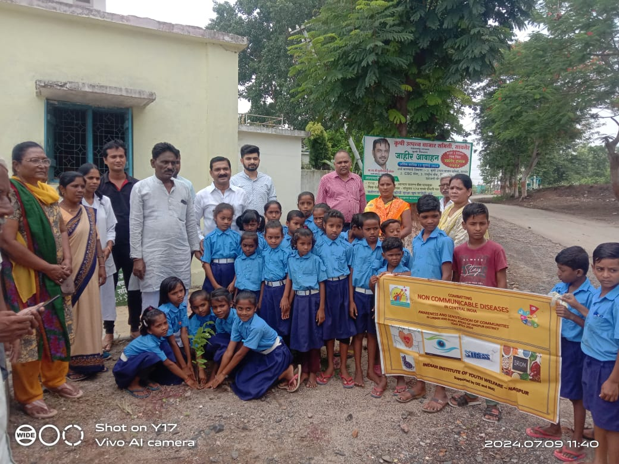
School rally on NCD in Saoner Block on 09-07-2024
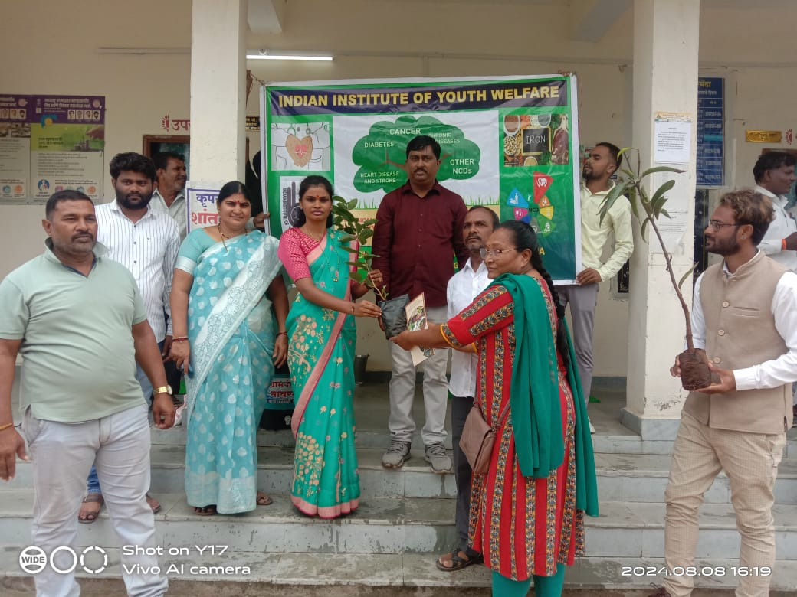
Distribution of plant saplings to Gram Panchayat at Sawarmendha on 08-08-2024
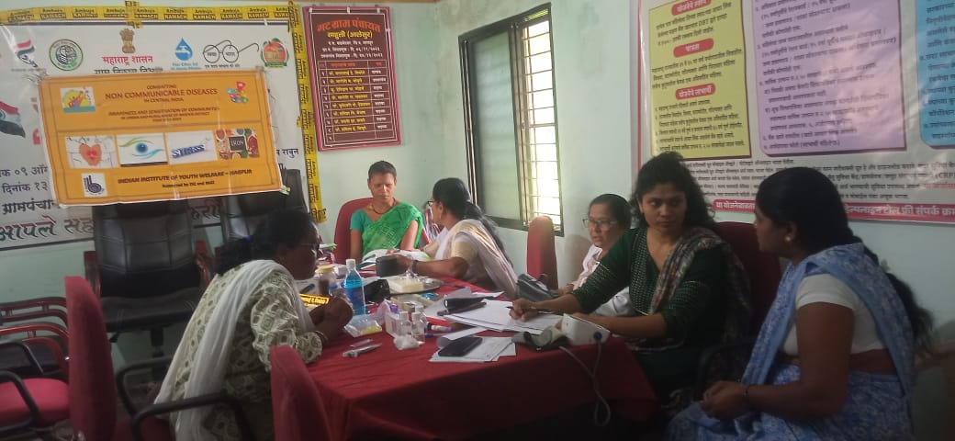
Health screening for HB testing of women in the reproductive age group at Sauli village at Primary Health Centre
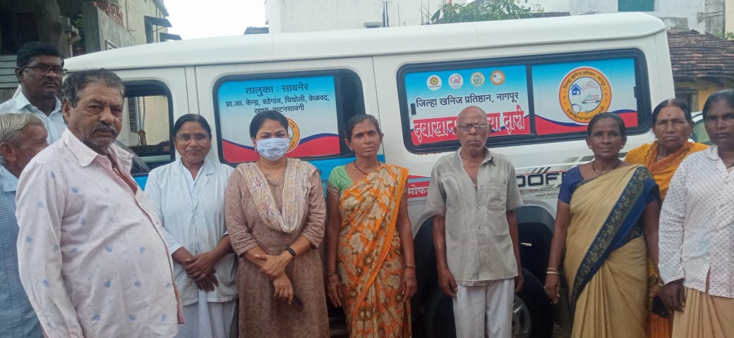
Government scheme of “Dawakhana Aplya Dari” - (Clinic at your door step) at Kelwad-Sanoer block
Health screening of old age people with the support of NCD project team

H
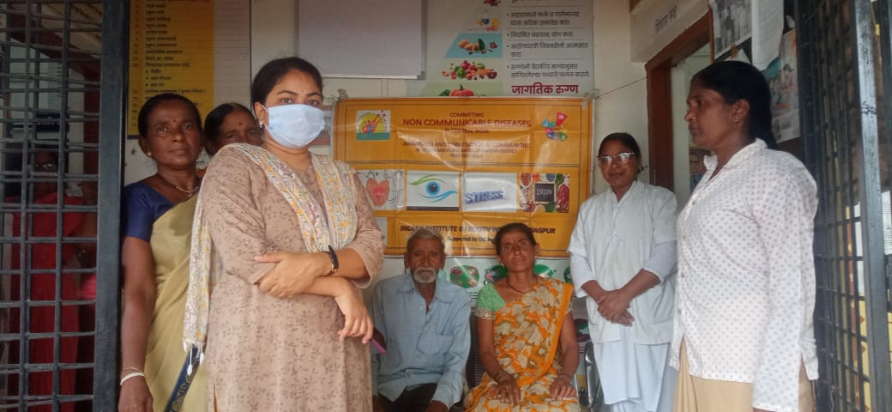
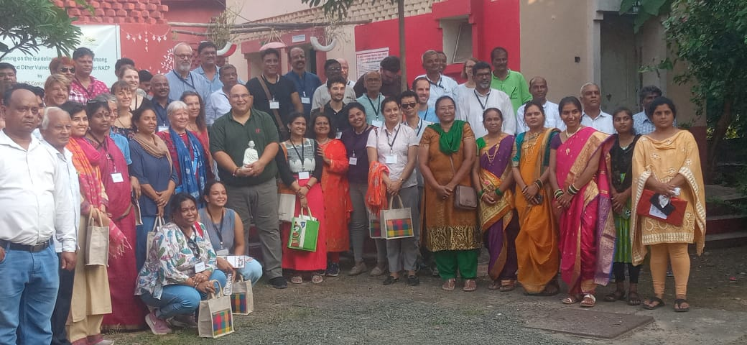
Visit by Dr Jona and Weltwart partners at Lonara Campus
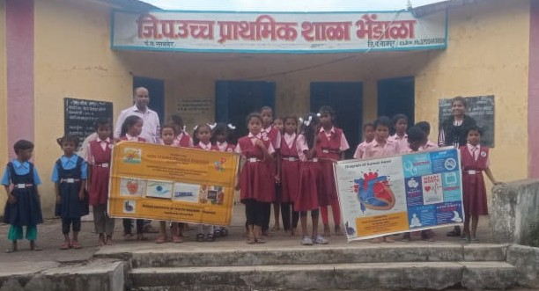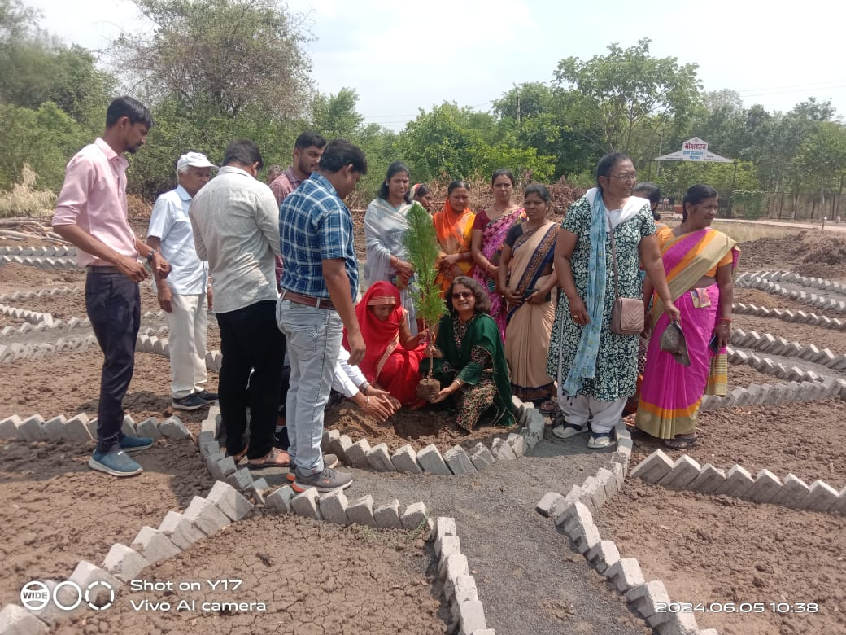
Interventions at Bhendala village
Awareness with Government Primary School
Round model of Organic Kitchen Garden and tree plantation with Gram Panchayat Members

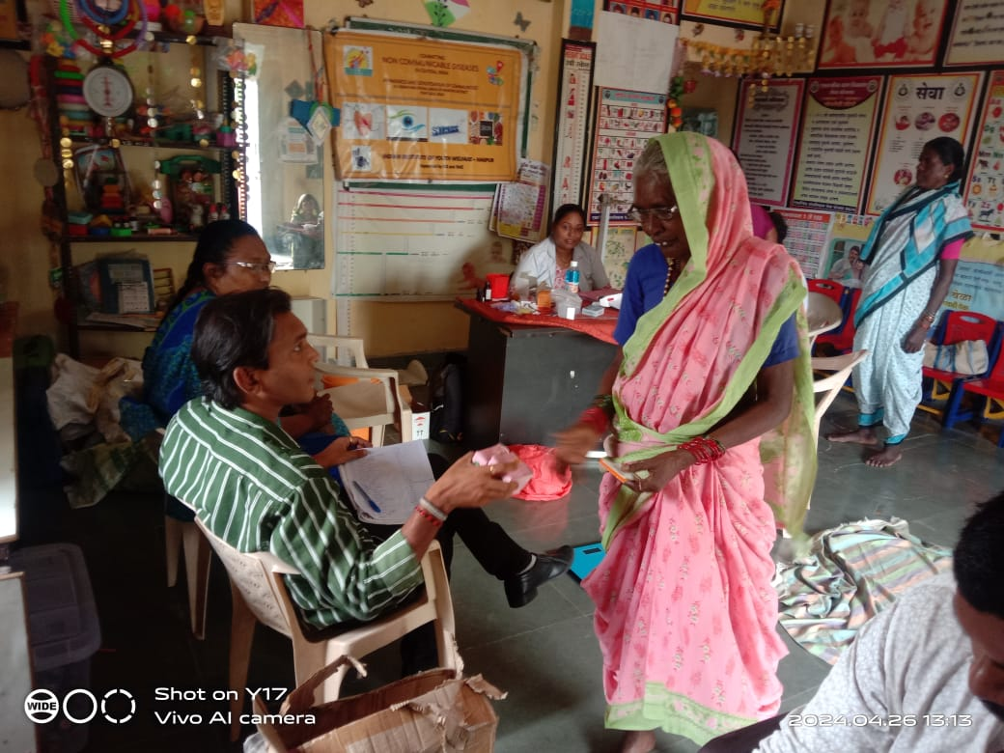
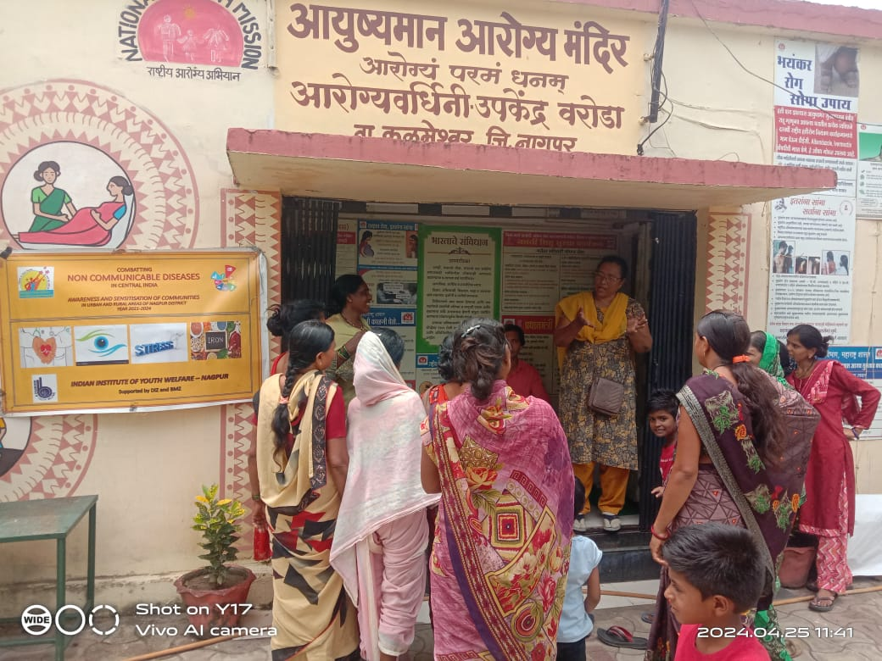
Health check ups for elderly and women at PHC sub centre at Waroda-Kalmeshwar Block on 26-04-2024
Awareness with Women Self Help group at Ayushmaan Arogya Mandir at Waroda - Kalmeshwar block.
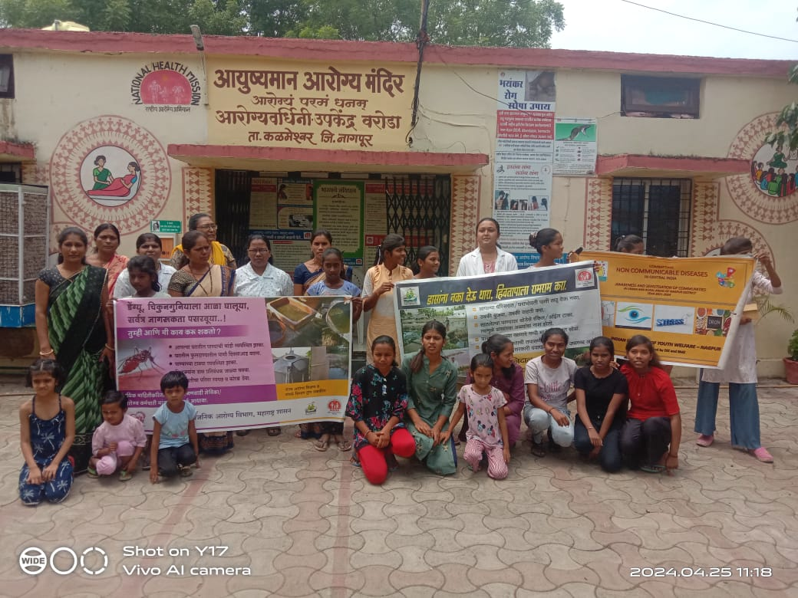
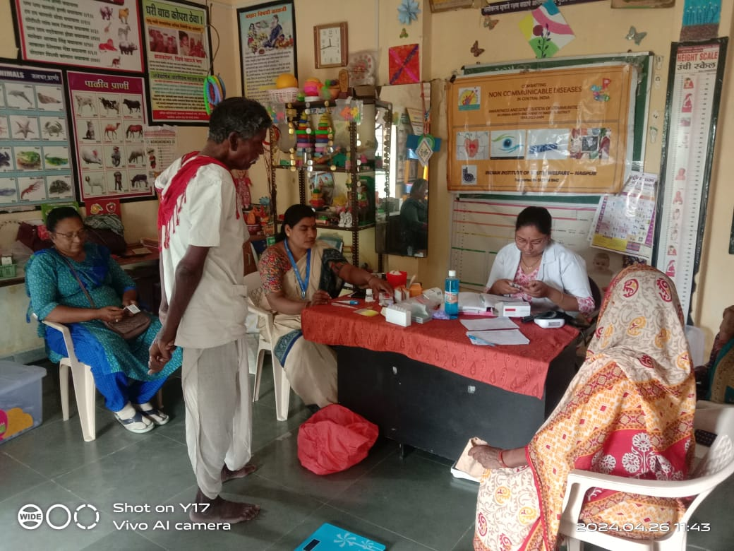
Ralli on “Prevention of Malaria and Fileria and Dengu” with PHC with participation of Dr. Mrs. Raut. On 25-04-2024 (Ayushmaan Arogya Mandir)
Health check ups for elderly and women at PHC sub centre at Waroda-Kalmeshwar Block on 26-04-2024
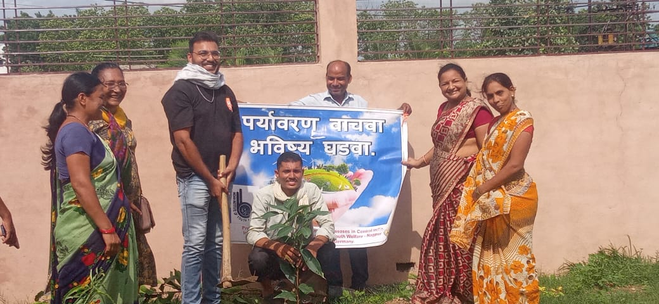
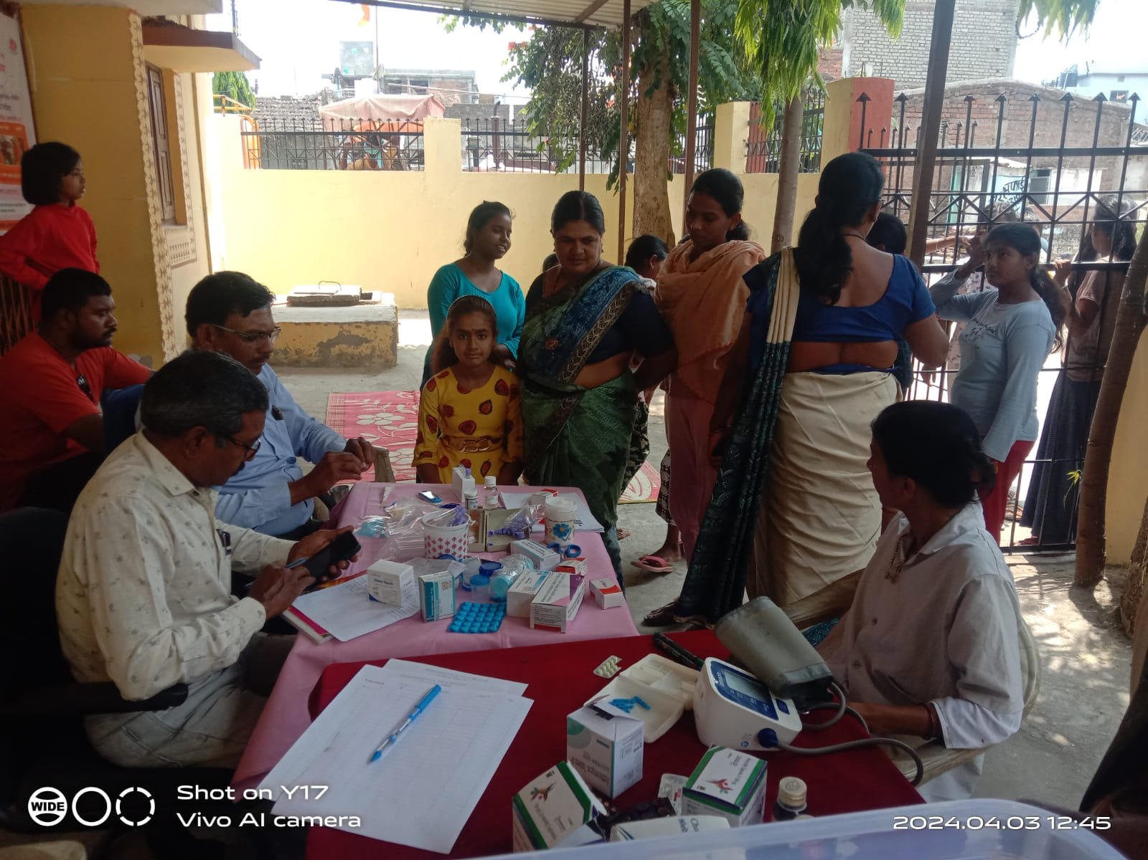
Tree plantation programme at Gumthi Gram Panchayat
Health screening of population and checking of Haemoglobin for women from age group of 18 to 49 at Chakki Khapa on 03-04-2024
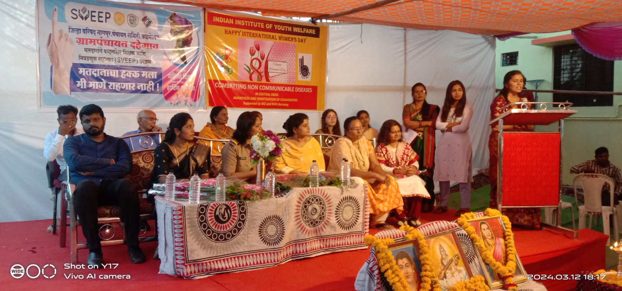
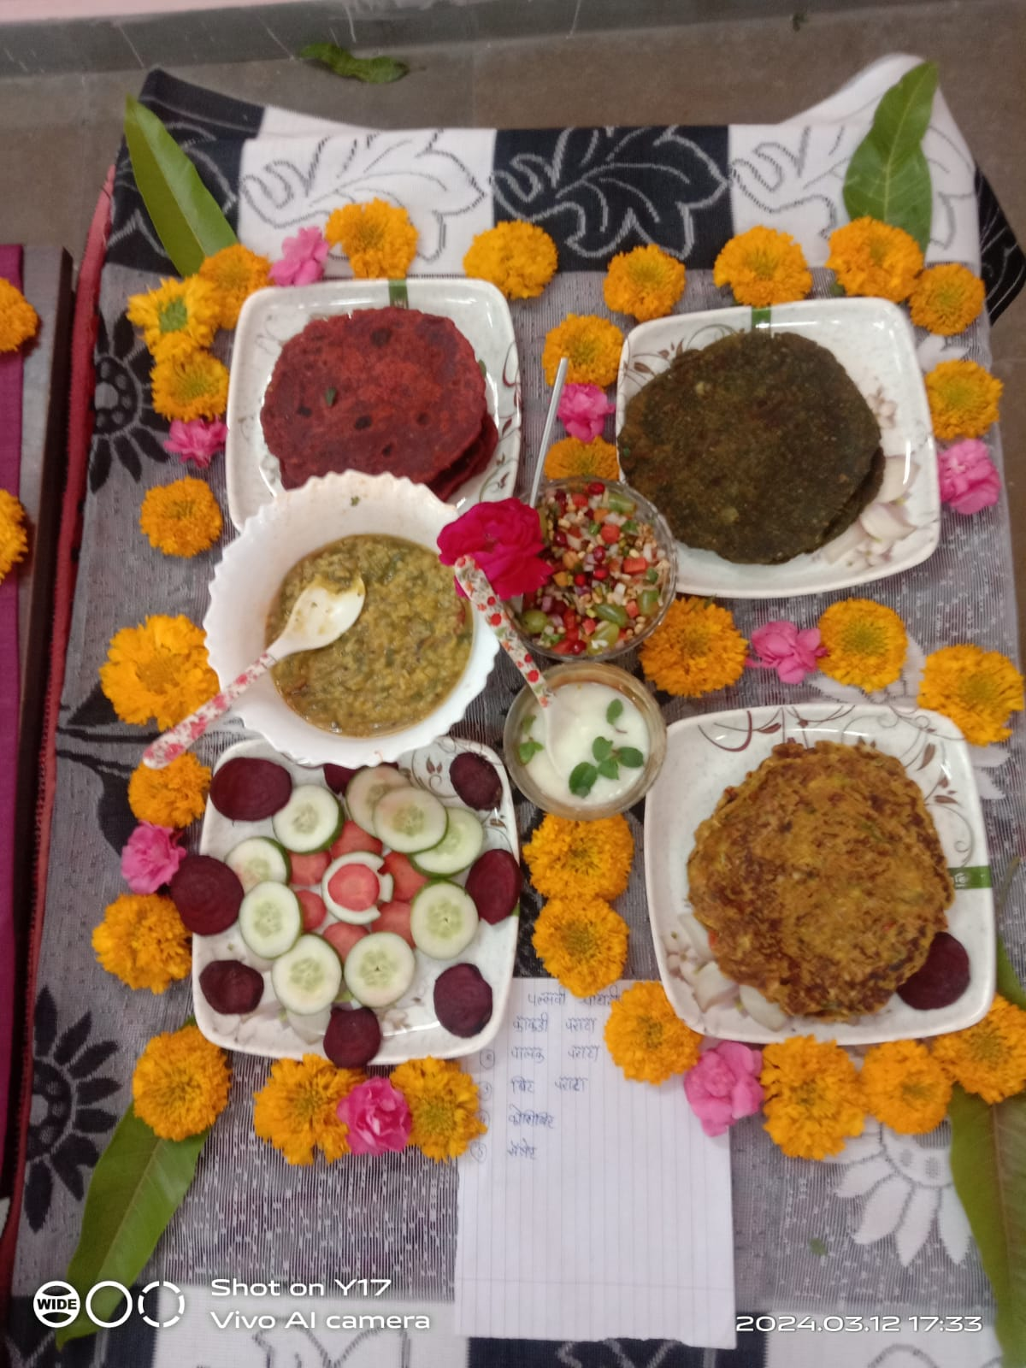
Recipe competition for Nutritious food for women to combat iron deficiency anaemia for Self Help Group at Dahegaon -during the Women’s empowerment week (12-03-2024).

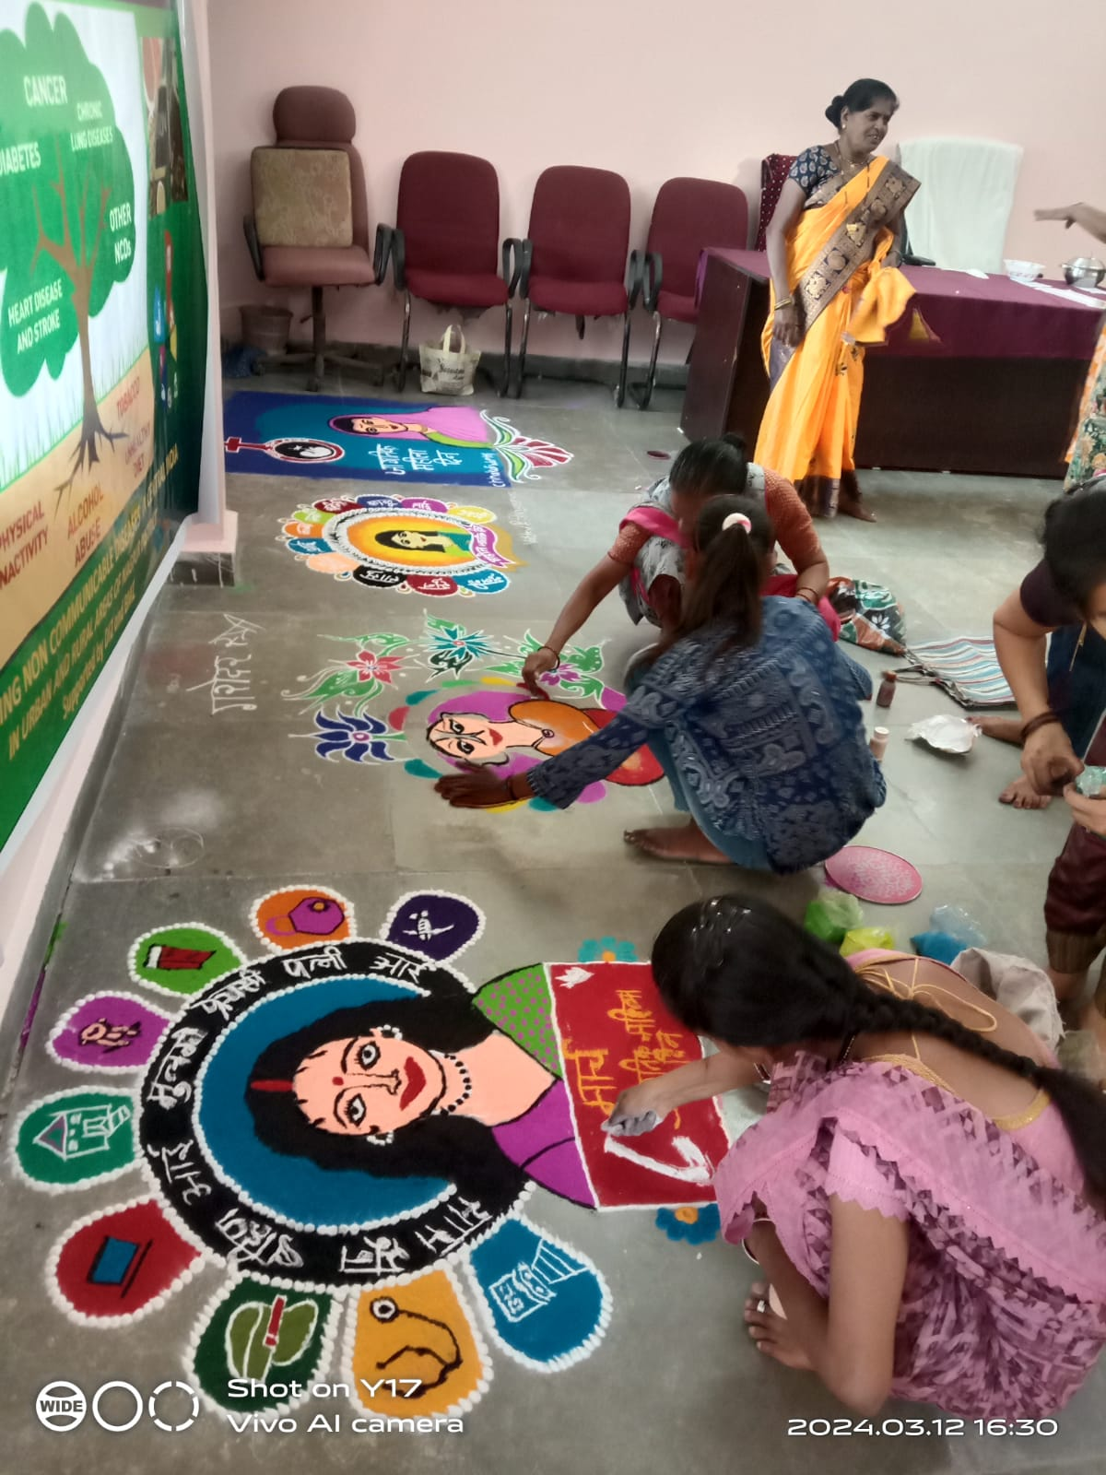
Awareness programme on NCD and competition for kids and Rangoli competition for Adolescents at Adasa village in collaboration with UMED programme of Government (11-03-2024)
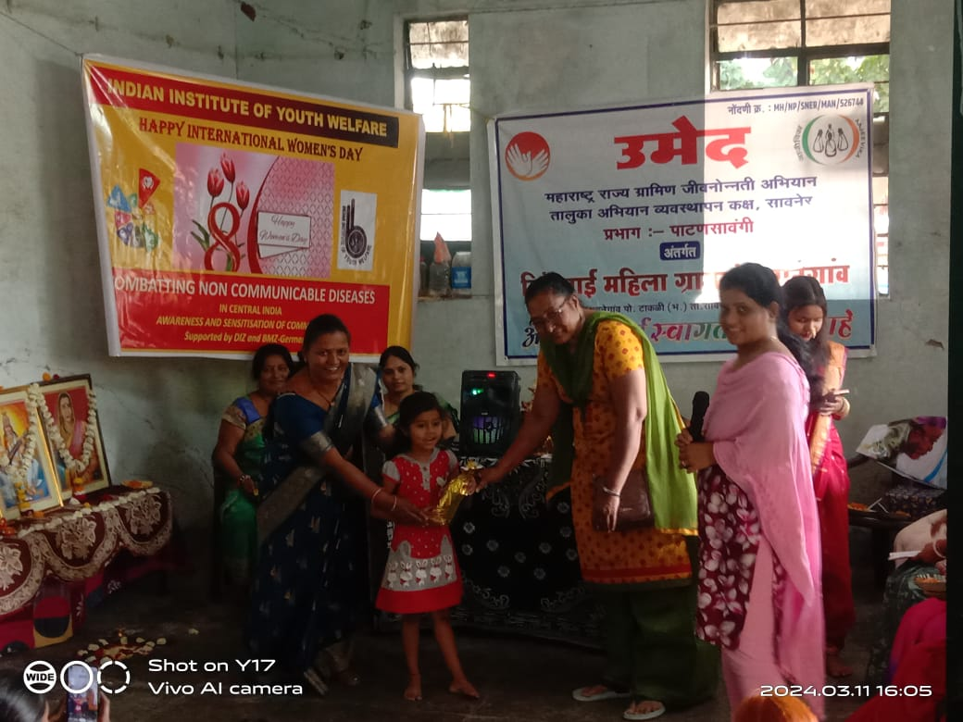

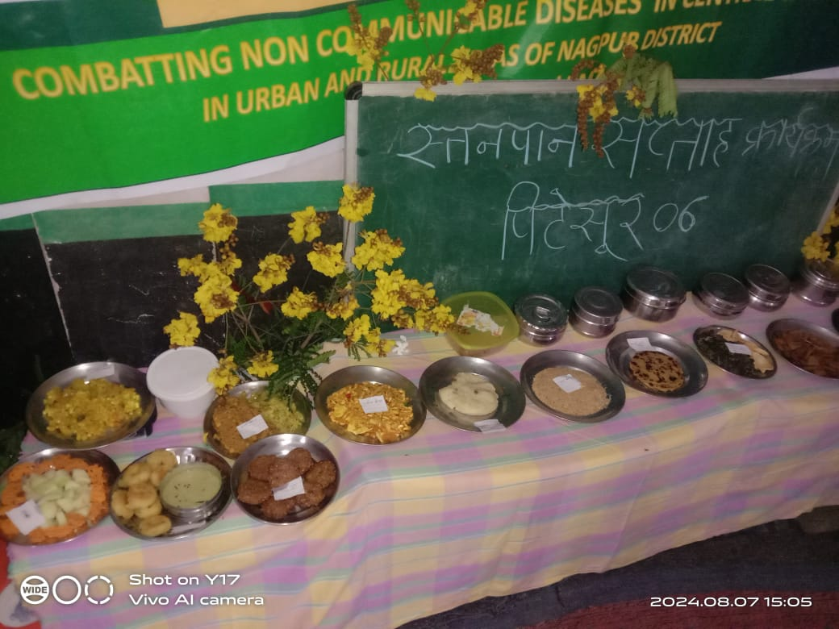
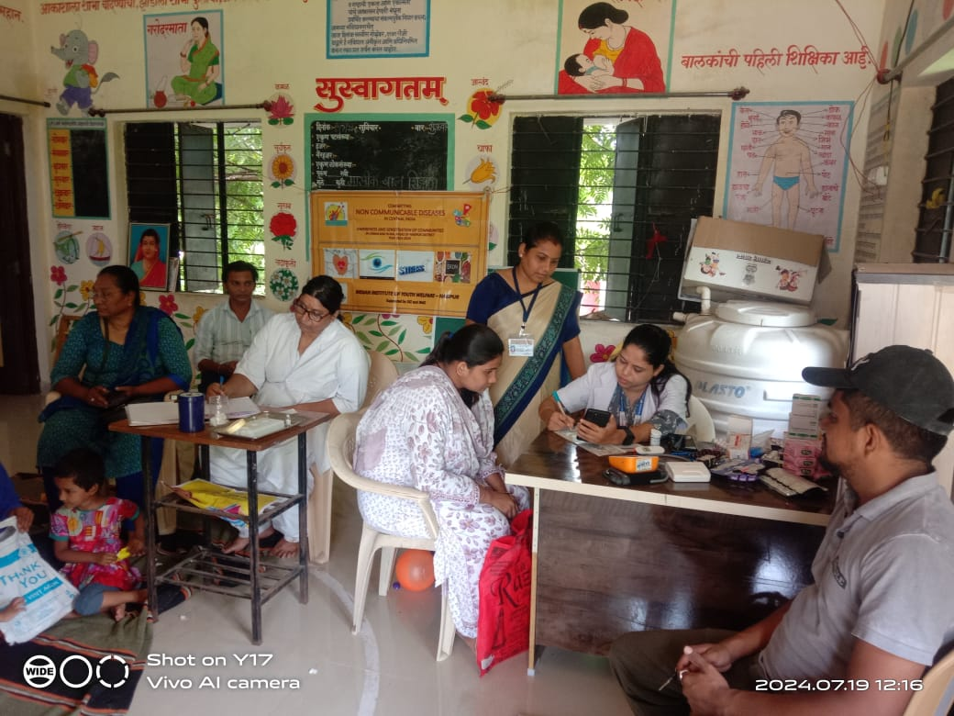
Health screening camp and nutritious recipe competition at Pitesur during World Breast feeding week (07-08-2024)
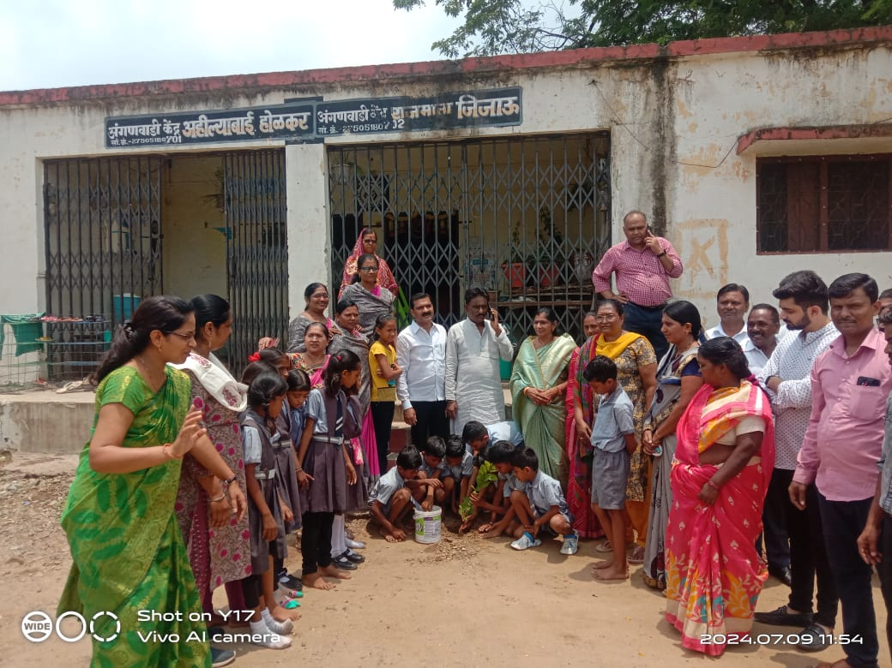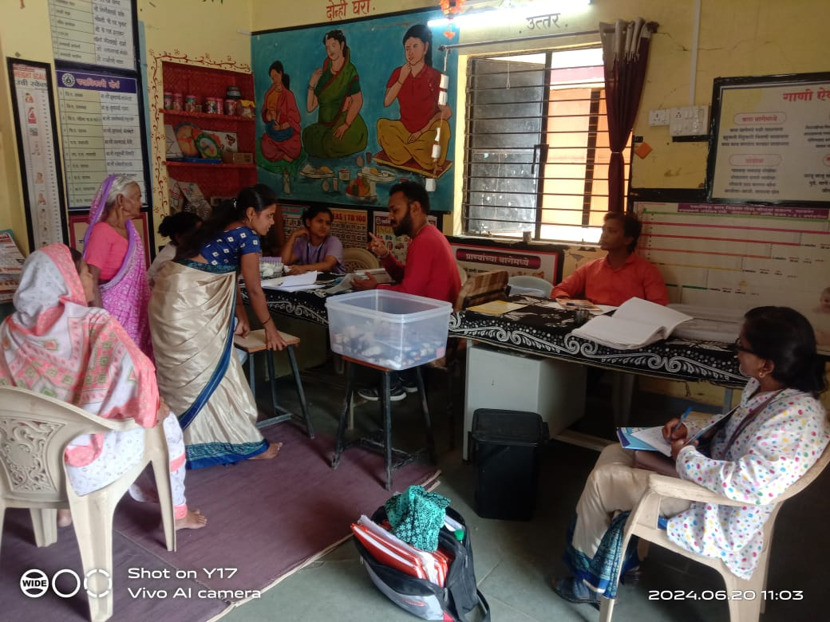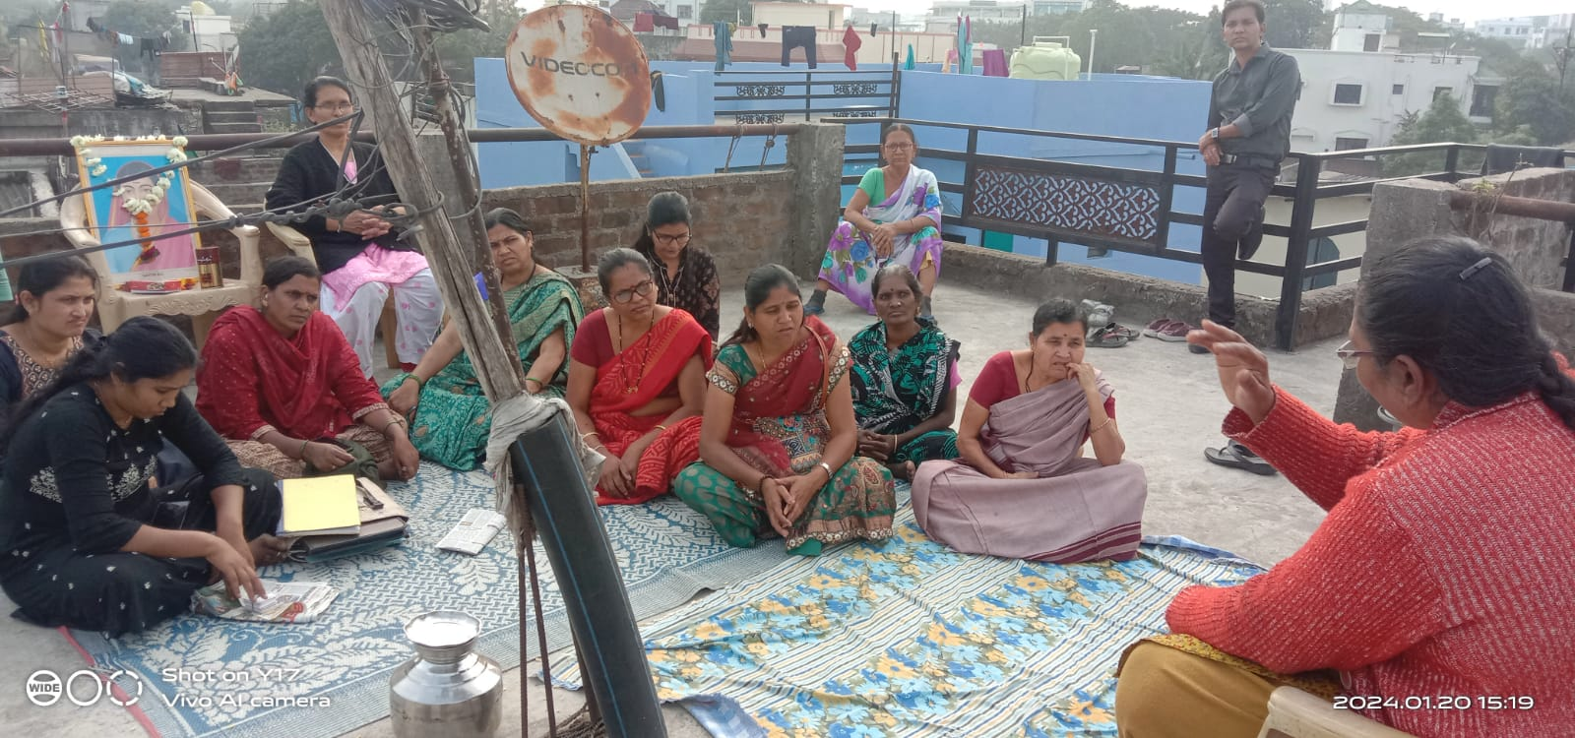
Tree plantation at Ahilyabai Holkar Anganwadi centre and Jijamata Anganwadi Centre
Health screening of women in village-Itanghoti in Kalmeshwar Block

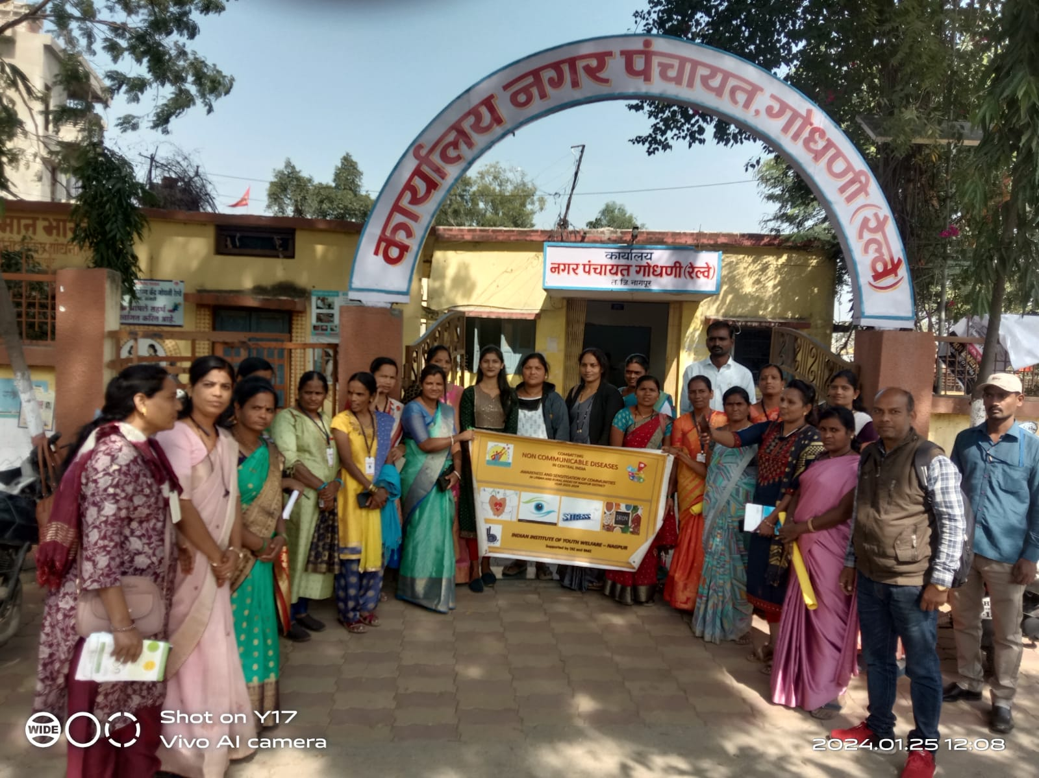
Rally and awareness programme on “Iron Deficiency Anaemia” with Gram Panchayat Godhni
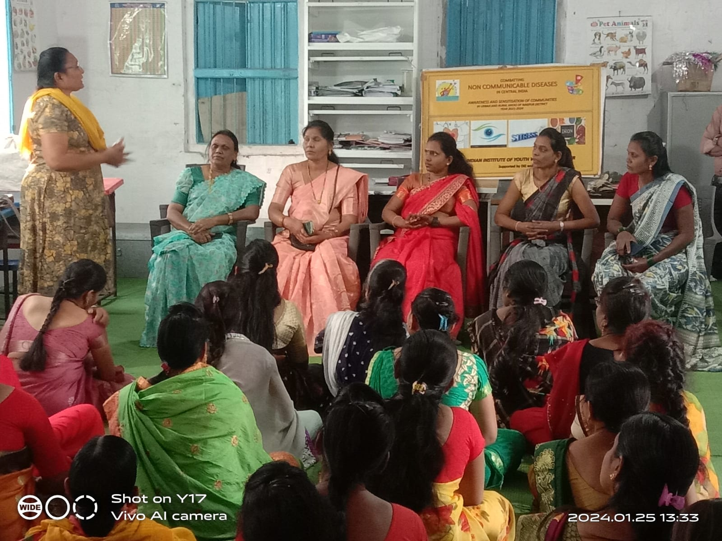
Awareness on Anaemia - at Zunki -Sahuli village -Saoner block

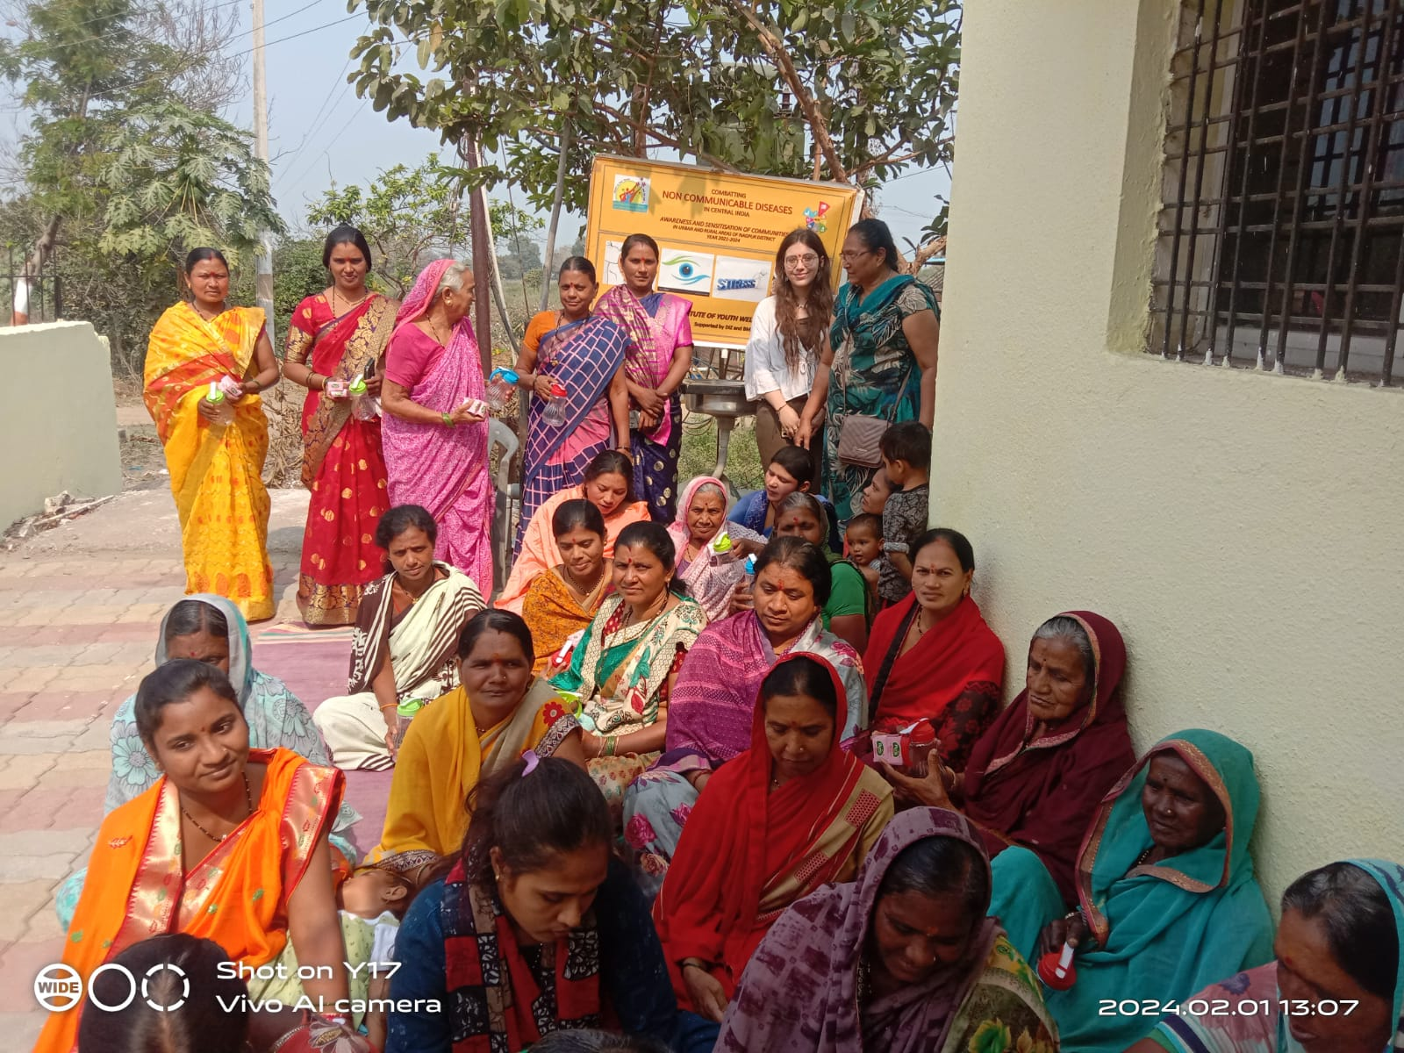
Self Help Group meeting and awareness on NCD during Sankranti programme as 01/02/2024
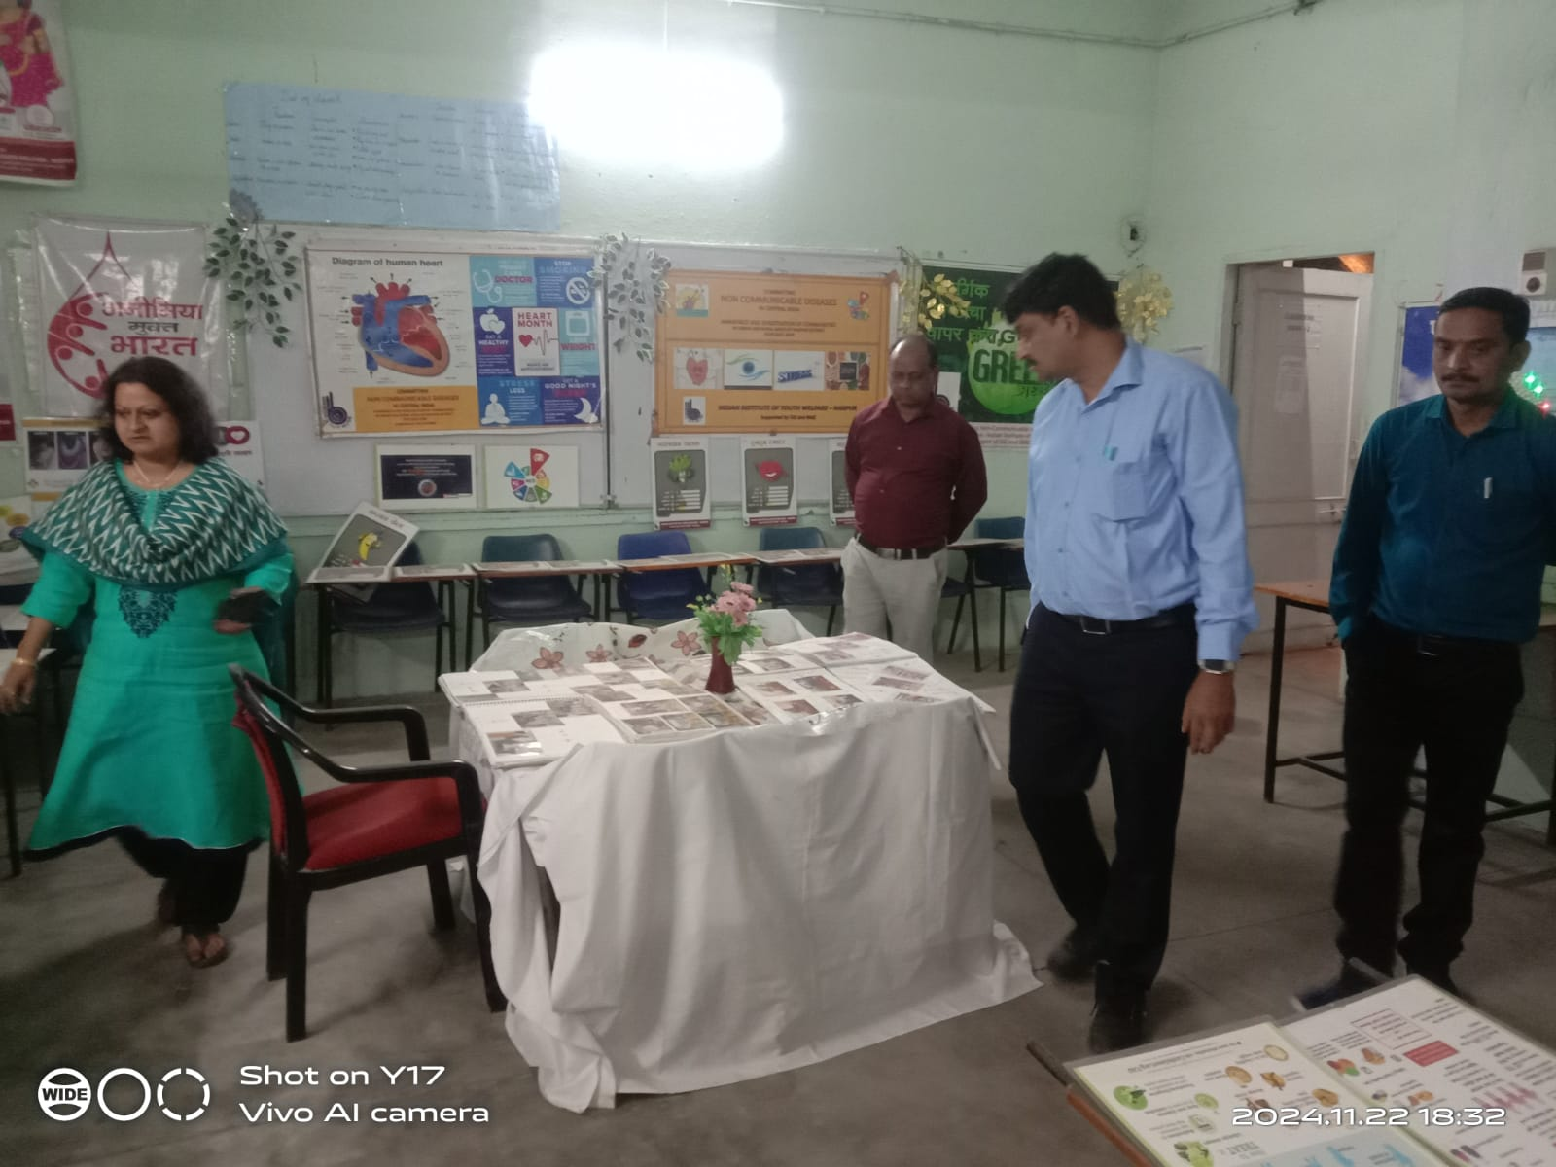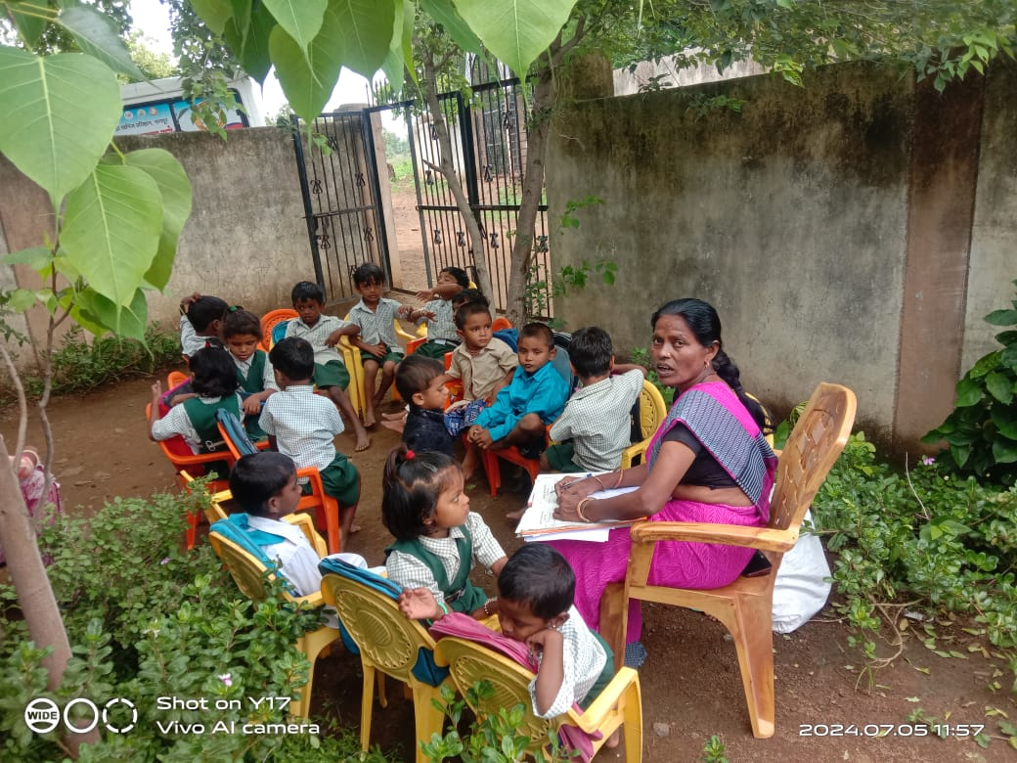
- Dr Rahul Jadhav overlooking NCD exhibition put up at lonara campus.
- School level organic kitchen garden development
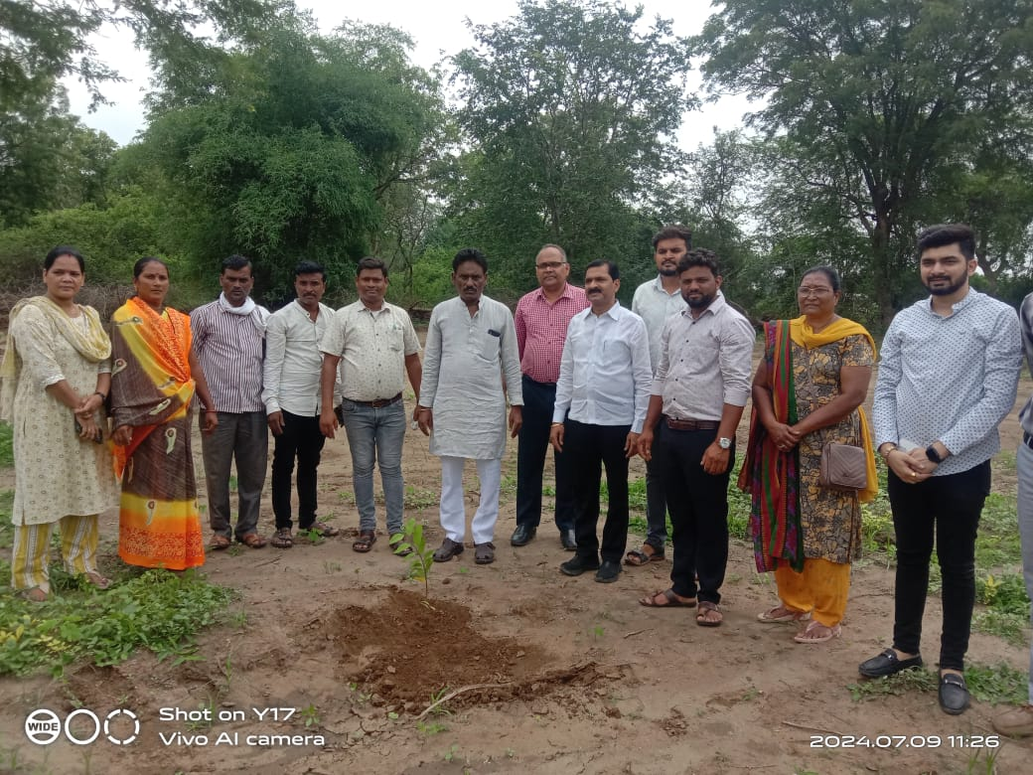
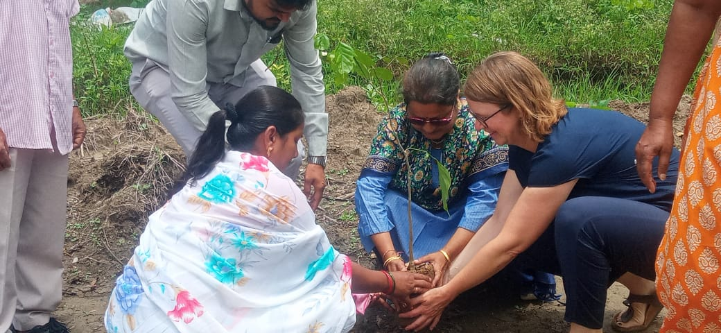
Bhendala village-
Tree plantation by Sybille and Dr Shilpa Mirashi-Director -IIYW
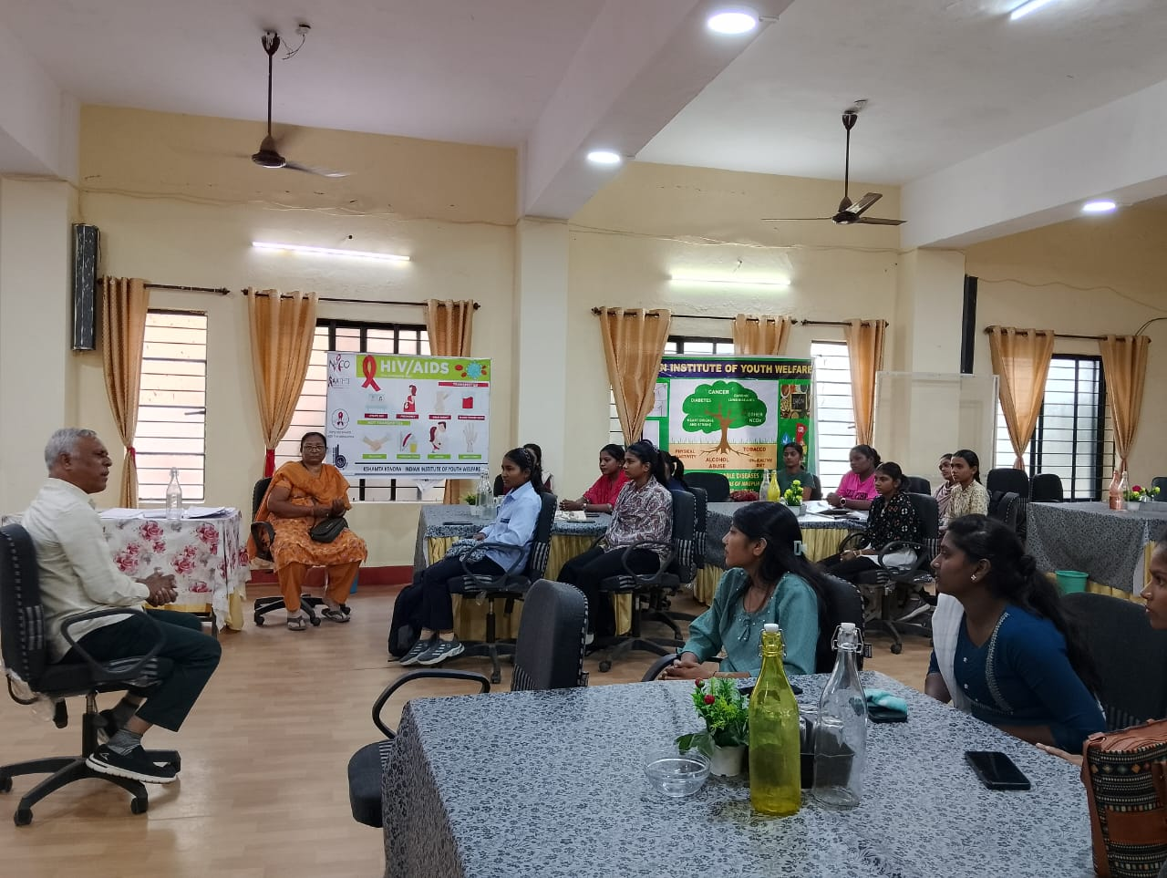
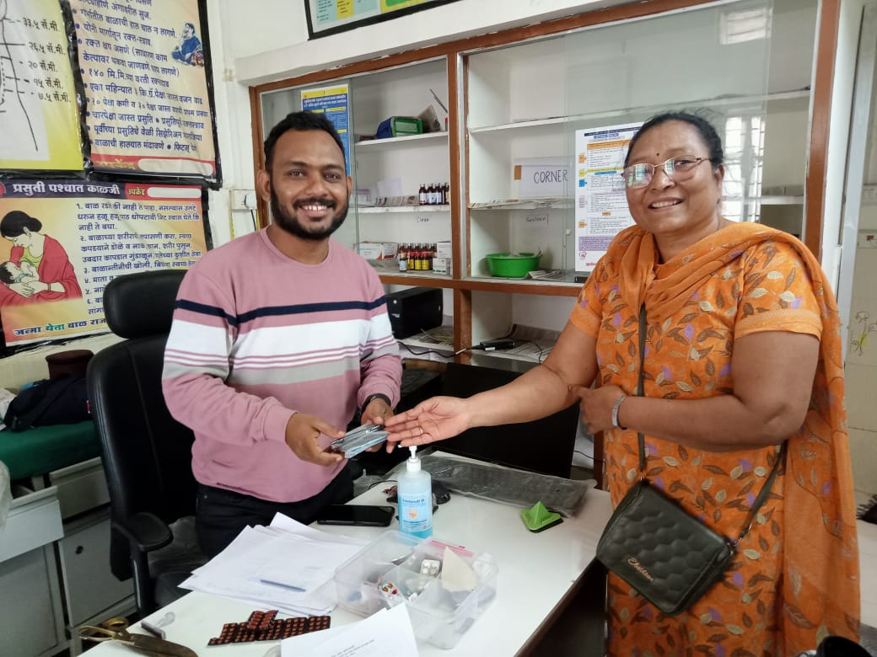
Future planning for NCD with adolescents from various villages.
Stakeholders feedback meeting and appreciation given by NCD team
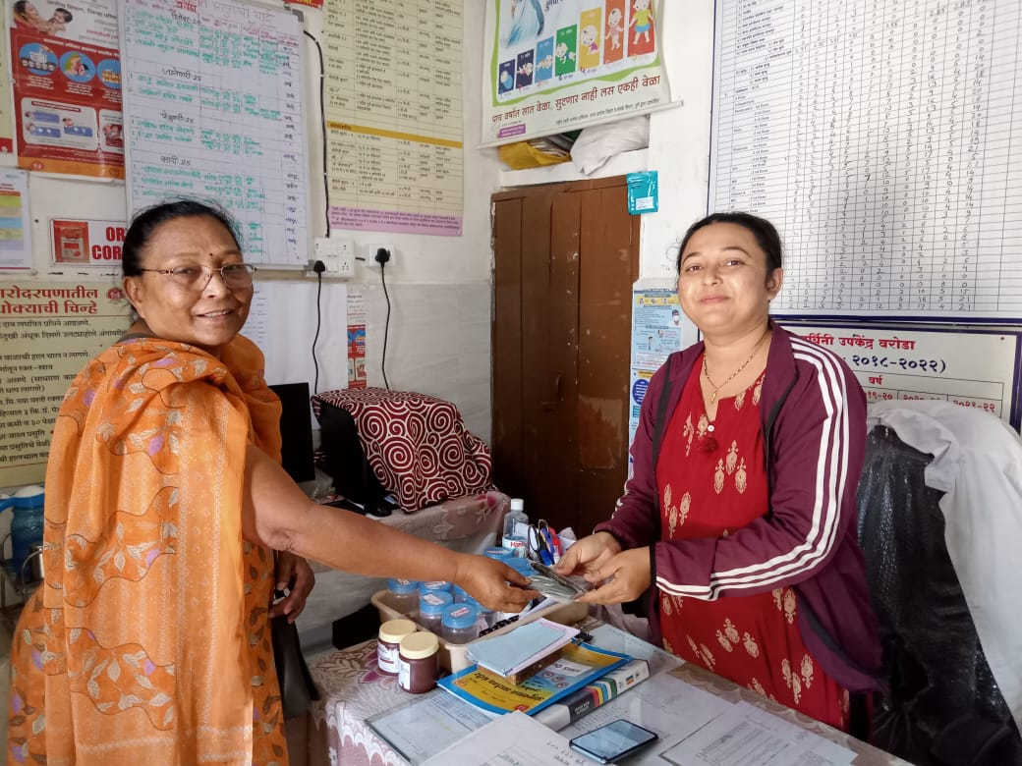
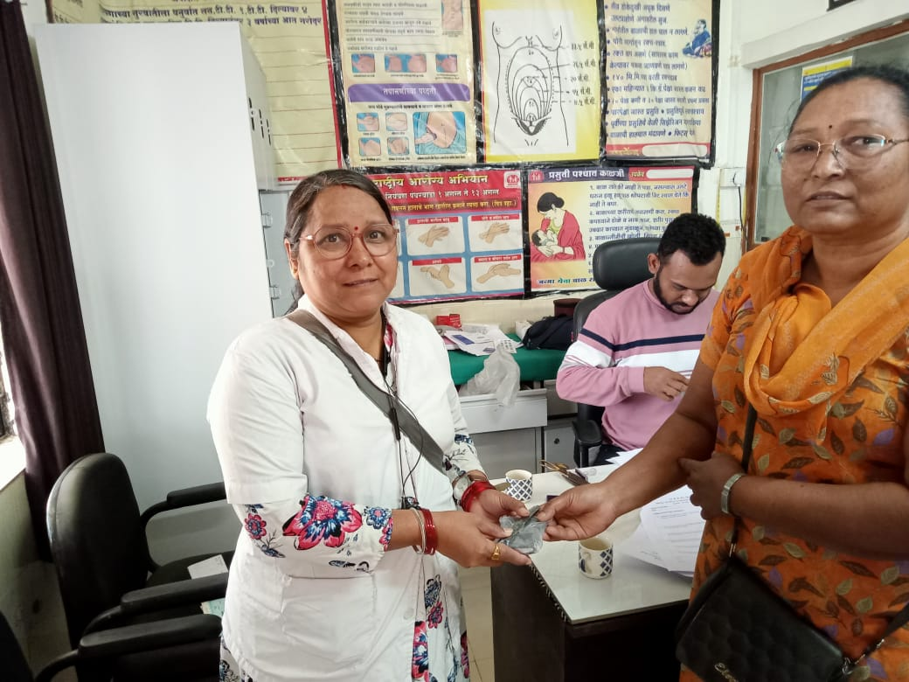
Stakeholders appreciation by NCD team
PHC Doctors- Dr Raut at Sawarmendha

From Kalmeshwar block, following 43 villages have been covered in year 2024-
Kalambi
Pardi deshmukh
Zunki
Sindi
Masepathar
Ghorad’
Kohli Mohli
Bhadangi
Nanda
Nimji
Kaniyadol
Borgaon
Sonegaon, wathoda

Brahmanwada
Bharatwada
Walni
Lonara
Chakki khapa
Lonkhairi
Bailwada’
Khandala
Bokhara
Gumthi
Dahegaon

Tondakhairi
Susundri
Pipla Kinkhed
Khumari
Bhadasawangi
Khapri Udgi
Sahuli
Mahurzari
Panubadi
Selu
Lohgad
Gumthala

From Saoner block , following villages have been covered
Itanghoti
Khubala
Manegaon
Nimtalai
Takli
Khairi dhal gaon’
Brahmapuri
Isapur
Sadar dhobipura
Goudmolla
Hajari pahad
Futala juni vasti
Surendra gad
Kachipura
Sudam Nagri
Anjani
Pipla dak bangl

From Dharampeth zone, following low income communities have been covered -
Champa
Nanda
Umri
Tighai
Bhendala
Sawarmendha
Dahegaon rangari
Sillori

Futala new vasti
Sanjay nagar
Krishna nagar
Pandhrabodi
Manavta nagar’
Mahapura
Rajiv gandhi nagar
Wakuli
Patansawangi

From the Laxmi nagar zone - following low income communities have been covered -
- Chunabhatti
- Ambika nagar
- Parsodi nagpur
- Gopal nagar
- Subhash nagar
- Kamgaar nagar
- Ambedkar nagar

SCHOOLS covered in 4 years of NCD intervention -
- Mahurzari ZP school
- Zp school kadambi and Wankhede
vidyalaya Kadambi
- ZP School Ubali
- ZP School Ghorad
- ZP School Sonegaon
- ZP School Khapri-Udgi
- ZP School Parsodi
- ZP School Isapur
- ZP School Godhni
- ZP School Sawarmendha
- ZP School Dahegaon
- ZP school Dahegaon Rangari
- ZP School Walni
- ZP school Wakuli
- ZP school Weltur
- ZP school Zunki
- ZP School Sindhi

- ZP school Bhendala
- ZP school Pimpa Dakbangla
- ZP school Manegaon
- ZP school Sahuli
- ZP school Gosewadi
- ZP school Sillori
- ZP school Champa
- ZP school Gumthi
- ZP school Bokhara
- ZP school Pitusur
- ZP school Chakki khapa
- ZP school Bharat wada
- ZP school Bhandangi
- ZP school Selu
- ZP school lonara
- Vrushali Primary school
- Krishna Vidyalaya
- ZP school Futala
- ZP school Sim Takli
- ZP school Borgaon

Thank you,

IIYW NCD TEAM.

